Art & Design

***Key Questions***

1. Name a type of media you can use to create a piece of artwork.
2. What word do we use to describe how light or dark a colour is?
3. What word do we use to show we have darkened or coloured a drawing?
4. What is an observational drawing?

***Key Vocabulary***

**Media:** The materials used to create a piece of artwork, for example, pastels, chalk, charcoal, crayons, pencils, paint.

**Shade:** To darken or colour a drawing with lines or blocks of colour.

**Tone:** The lightness or darkness of a colour.

**Observational drawing:** Drawing what you see.

**Scale:** A drawing that has been made bigger or smaller than its original size.

**Sculpture:** A 3D piece of artwork.

**Artist:** A person who creates artwork, for example, paintings, drawings, sculptures.

Geography

***Key Questions***

1. What are the names of the 7 continents?
2. What are the names of the five oceans?
3. What is the weather like in the hot places of the world (near the equator)?
4. What is the weather like in the cold places of the world (near the North and South Poles)?
5. What sorts of animals live in hot or cold places?
6. How have these animals adapted to their environment?
7. What are some human and physical features if hot and cold places of the world?

***Key Vocabulary***

**Continent:** A continent is a large continuous mass of land conventionally regarded as a collective region. There are seven continents: Asia, Africa, North America, South America, Antarctica, Europe, and Australia (listed from largest to smallest in size).

**Ocean:** An ocean is a huge body of salt water

**Weather:** Weather is the way the air and the atmosphere feel. It includes the outside temperature, strength of the wind, and whether it is raining, sunny, hailing, snowing, sleeting, foggy, or cloudy.

**Equator:** An imaginary line around the Earth that goes exactly midway between the North Pole and the South Pole and divides it into two equal halves, the Northern Hemisphere and the Southern Hemisphere.

**North and South Poles:** The northernmost and southern most point of the Earth.

Lead subjects Geography, Art & Design and Science

Year 1 Penguins, Possums and Pigs

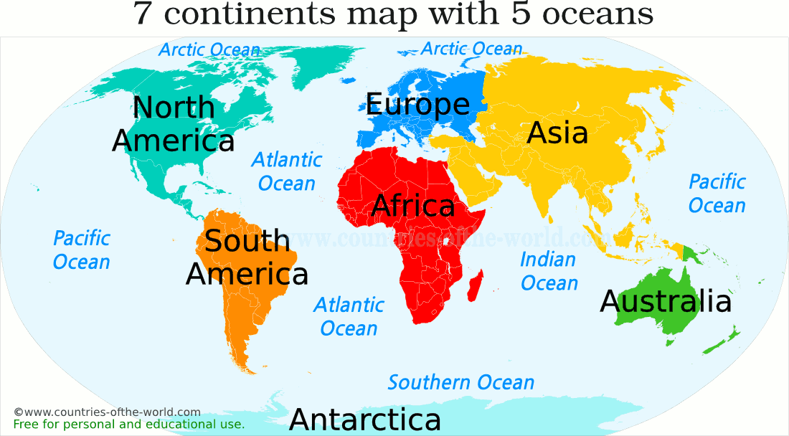

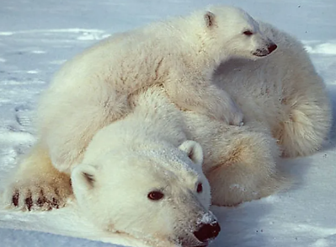

Science

***Key Questions***

1. What is a mammal?
2. What is a bird?
3. What is a reptile?
4. What is an amphibian?
5. What is a fish?
6. What does a herbivore eat?
7. What does a carnivore eat?
8. What does an omnivore eat?

***Key Vocabulary***

**Mammal, bird, reptile, amphibian, fish:** see information to the right.

**Herbivore:** An animal that feeds on plants.

**Carnivore:** An animal that feeds on meat.

**Omnivore:** An animal that feeds on plants and meat.

**Scales:** Fish have scales as a protective skin. The scales grow out of the body of the fish. Reptiles have hard scales covering their skin to protect their body.

**Cold blooded animals:** Cold blooded animals are always the same temperature as the environment they are in. They cannot warm up or cool down on their own. If their environment is warm they get warm and if their environment is cold they get cold.

**Warm blooded animals:** Warm blooded animals are always warm. They try to keep their body the same temperature. If they are cold, they will make their own heat and if they are hot they will cool themselves down.