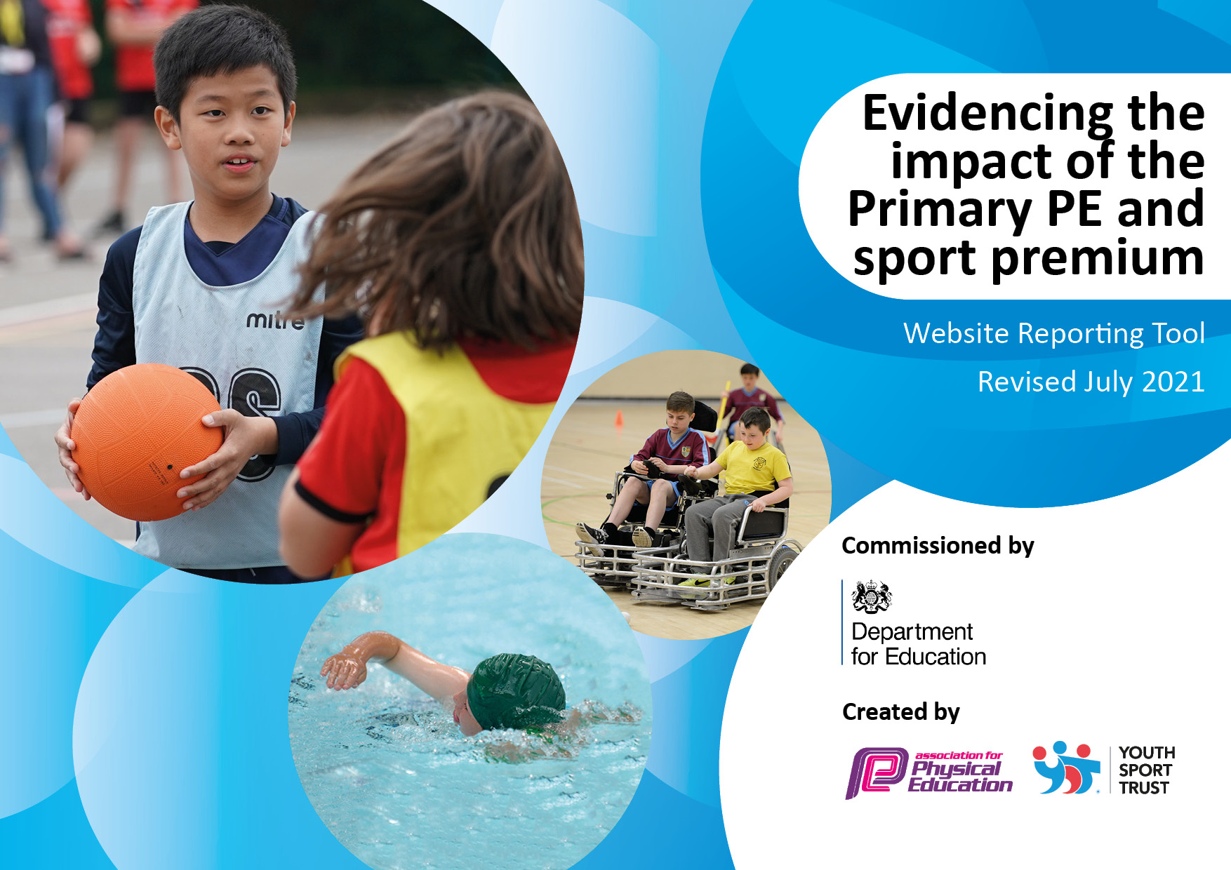
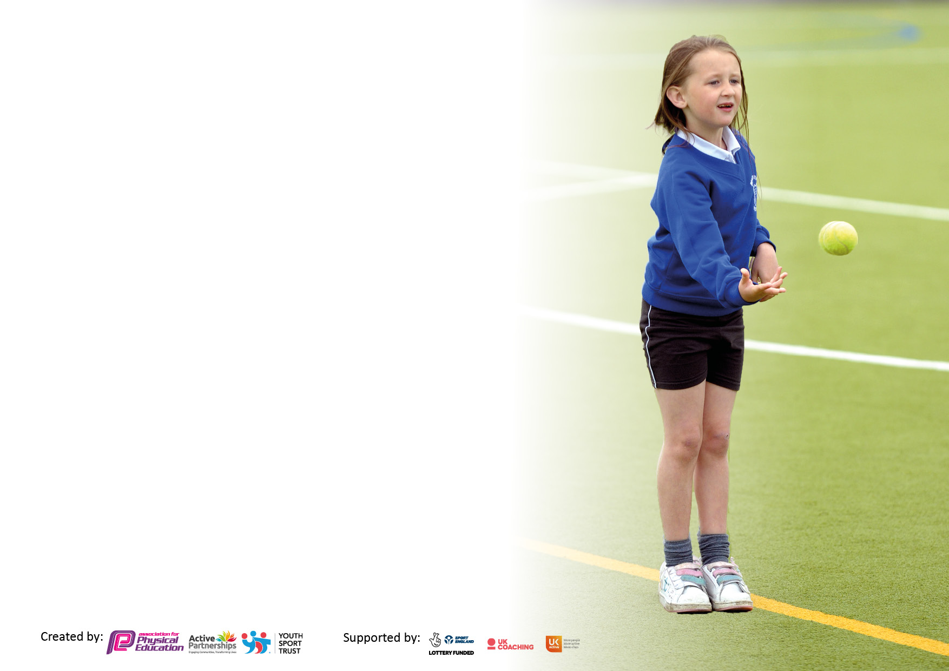

It is important that your grant is used effectively and based on school need. The Education Inspection Framework makes clear there will be a focus on ‘whether leaders and those responsible for governors all understand their respective roles and perform these in a way that enhances the effectiveness of the school’.

Under the Quality of Education Ofsted inspectors consider:
Intent - Curriculum design, coverage and appropriateness
Implementation - Curriculum delivery, Teaching (pedagogy) and Assessment
Impact - Attainment and progress

To assist schools with common transferable language this template has been developed to utilise the same three headings which should make your plans easily transferable between working documents.

Schools must use the funding to make additional and sustainable improvements to the quality of Physical Education, School Sport and Physical Activity (PESSPA) they offer. This means that you should use the Primary PE and sport premium to:

- Develop or add to the PESSPA activities that your school already offer
- Build capacity and capability within the school to ensure that improvements made now will benefit pupils joining the school in future years
- The Primary PE and sport premium should not be used to fund capital spend projects; the school’s budget should fund these.

Pleasevisitgov.ukfortherevisedDfEguidanceincludingthe5keyindicatorsacrosswhichschoolsshoulddemonstrate animprovement.Thisdocumentwillhelpyoutoreviewyourprovisionandtoreportyourspend.DfEencouragesschools to use this template as an effective way of meeting the reporting requirements of the Primary PE and sport premium.

We recommend you start by reflecting on the impact of current provision and reviewing the previous spend.

Schools are required to publish details of how they spend this funding, including any under-spend from 2019/2020, as well as on the impact it has on pupils’ PE and sport participation and attainment. All funding must be spent by 31st July 2022.

We recommend regularly updating the table and publishing it on your website throughout the year. This evidences your ongoing self-evaluation of how you are using the funding to secure maximum, sustainable impact. Final copy must be posted on your website by the end of the academic year and no later than the 31st July 2021. To see an example of how to complete the table please click HERE.
Created by: Supported by:

Details with regard to funding
Please complete the table below.

Total amount carried over from 2019/20 | £0
Total amount allocated for 2020/21 | £18,500
How much (if any) do you intend to carry over from this total fund into 2021/22? | £0
Total amount allocated for 2021/22 | £18,500
Total amount of funding for 2021/22. To be spent and reported on by 31st July 2022. | £18,500
Swimming Data
Please report on your Swimming Data below.

Meeting national curriculum requirements for swimming and water safety.  N.B. Complete this section to your best ability. For example you might have practised safe self-rescue techniques on dry land which you can then transfer to the pool when school swimming restarts.  Due to exceptional circumstances priority should be given to ensuring that pupils can perform safe self rescue even if they do not fully meet the first two requirements of the NC programme of study | 31%
What percentage of your current Year 6 cohort swim competently, confidently and proficiently over a distance of at least 25 metres?  N.B. Even though your pupils may swim in another year please report on their attainment on leaving primary school at the end of the summer term 2021.  Please see note above | 31%
What percentage of your current Year 6 cohort use a range of strokes effectively [for example, front crawl, backstroke and breaststroke?  Please see note above | 31%
What percentage of your current Year 6 cohort perform safe self-rescue in different water-based situations? | 31%
Schools can choose to use the Primary PE and sport premium to provide additional provision for swimming but this must be for activity over and above the national curriculum requirements. Have you used it in this way? | Yes/No

Action Plan and Budget Tracking
Capture your intended annual spend against the 5 key indicators. Clarify the success criteria and evidence of impact that you intend to measure to evaluate for pupils today and for the future.

Academic Year: 2021/22 | Total fund allocated:18,500 | Date Updated:26.7.22
Key indicator 1: The engagement of all pupils in regular physical activity – Chief Medical Officers guidelines recommend that primary school pupils undertake at least 30 minutes of physical activity a day in school |  |  |  | Percentage of total allocation:
 |  |  |  | 72%
Intent | Implementation |  | Impact
Your school focus should be clear what you want the pupils to know and be able to do and about  what they need to learn and to  consolidate through practice: | Make sure your actions to achieve are linked to your intentions: | Funding allocated: | Evidence of impact: what do pupils now know and what can they now do? What has changed?: | Sustainability and suggested next steps:
To ensure that the children have access to the equipment they need to use during their PE lessons.  To ensure that the children have access to equipment during playtimes to encourage them to be physically active at these times.  To give the children in EYFS the chance to develop the skills needed to ride a bike. | We carried out an audit to identify the equipment we needed to deliver the curriculum effectively to maximise the involvement of all children in PE lessons. We then purchased this equipment.  Our children enjoy playing team games at break times, but we lacked adequate targets for then to use so we decided to purchase goal ends to overcome this and enhance the children’s enjoyment.  The PE teacher from St Paul’s secondary school delivered the Balanceability sessions to children in EYFS2. | £895  £12,165  £200 | Children report that they enjoy their PE lessons as they have enough equipment for them to participate all the time during these lessons. The correct equipment for each sport we offer is being used.  We have ordered the Goal ends, and these will be fitted during the Summer holiday. These will allow the children to enjoy different team games.  The children in EYFS developed in confidence during the 6-week block and some were able to progress onto riding a bike with pedals. | Continue to audit PE resources regularly and order new equipment as needed. Carry out pupil interviews to check children can participate fully during PE lessons and that they are enjoying them.  Discuss with staff and children how the new equipment will be used fairly so all children get the opportunity to use the goal ends. The school council could support this discussion in classes and feed back to the PE lead.  Book these sessions again for children in EYFS.
Key indicator 2: The profile of PESSPA being raised across the school as a tool for whole school improvement |  |  |  | Percentage of total allocation:
 |  |  |  | 1%
Intent | Implementation |  | Impact
Your school focus should be clear what you want the pupils to know and be able to do and about  what they need to learn and to  consolidate through practice: | Make sure your actions to achieve are linked to your intentions: | Funding allocated: | Evidence of impact: what do pupils now know and what can they now do? What has changed?: | Sustainability and suggested next steps:
To update the PE display board frequently.  To display the PE board in a frequently used corridor, allowing for all pupils and staff to see it.  To encourage disengaged girls to participate more in physical activity.  To train our Year 5 and 6 children to deliver physical activities to children in KS1 and EYFS. | We printed photographs of children at different sporting events and displayed these on the PE notice board. We put photographs on the school Twitter feed.  We booked a mini WHISPA for disengaged girls in Years 3 and 4.  The PE teacher from St Paul’s secondary school delivered Young Leader training to all children in Years 5 and 6. The Sports Coach then set up a rota for the children to deliver activities to children in EYFS and KS1 during playtime. | Printing costs  £60  £150 | Pupils have been able to see the different competitions we have entered and how the children have performed. This has motivated other children to aspire to being chosen for these teams in the future.  The girls reported that they really enjoyed these sessions and the coach running them commented on how much the girls’ confidence had improved over the 6 weeks. Class teachers and the Sports Coach reported that the girls were now more confident in PE lessons and were more willing to participate. The Sports Coach attended each session and so would be able to use these ideas to run sessions himself.  The children in Years 5 and 6 enjoyed delivering the sessions and it encouraged them to work as part of a team as we paired a more confident child with a less confident child. Many children in EYFS and KS1 participated in the activities as they enjoyed them and the interaction with the older children. | Continue to promote sporting achievements on the notice board, Twitter and in newsletters.  Book the WHISPA programme for next year to target other girls who are disengaged in sport. Consider the Sports coach running similar sessions for boys who are disengaged.  Children in Year 6 can start running activities during the Autumn term and we will arrange for the children in Year 5 to have the training so they can then run activities starting in the Spring term.

Key indicator 3: Increased confidence, knowledge and skills of all staff in teaching PE and sport. |  |  |  | Percentage of total allocation:
 |  |  |  | 2.9%
Intent | Implementation |  | Impact
Your school focus should be clear | Make sure your actions to | Funding | Evidence of impact: what do | Sustainability and suggested
what you want the pupils to know | achieve are linked to your | allocated: | pupils now know and what | next steps:
and be able to do and about | intentions: |  | can they now do? What has
what they need to learn and to |  |  | changed?:
consolidate through practice:
To ensure that staff can plan and deliver high quality PE lessons confidently and that children are given the opportunity to take part in and improve in a variety of areas of PE.  To ensure staff access relevant training to support their ability to deliver high quality PE lessons. | We continued to subscribe to the PE Hub so teachers have access to the scheme of work.  The newly employed Sports Coach worked alongside our experienced teachers as they demonstrated how to deliver high quality gymnastics and dance lessons.  There has been continual collaboration between teachers and coach to ensure high level in PE teaching is maintained.  The Sports Coach attended gymnastics training. | £540  This training was available as part of our SSPAN membership. See KI5 | All staff have continued to follow the scheme of work and it is continuing to be a very useful tool to ensure delivery of high-quality PE lessons.  During previous years our teachers benefitted from working alongside our experienced Sports coach to improve their skills in teaching PE so they were able to support our newly appointed sports coach to help him to deliver high quality gymnastics and dance lessons.  This training supported the Sports Coach’s understanding of what is required when teaching curriculum gymnastics. | Continue to subscribe to the PE Hub scheme of work.  Class teachers and the Sports Coach will continue to have the confidence to deliver the different aspects of PE lessons so children will receive high quality PE lessons.  Continue to access training for all staff as required.
Key indicator 4: Broader experience of a range of sports and activities offered to all pupils |  |  |  | Percentage of total allocation:
 |  |  |  | 10.8%
Intent | Implementation |  | Impact
Your school focus should be clear | Make sure your actions to | Funding | Evidence of impact: what do | Sustainability and suggested
what you want the pupils to know | achieve are linked to your | allocated: | pupils now know and what | next steps:
and be able to do and about | intentions: |  | can they now do? What has
what they need to learn and to |  |  | changed?:
consolidate through practice:
Additional achievements:  To increase the number of pupils participating in various sports and activities.  To use external companies and sports coach to deliver a range of sports after school.  To ensure that children access a range of sports during curriculum time. | A variety of after school clubs have taken place and have been run by our Sports Coach, teachers and TAs.  We had a taster session for all children in KS2 for archery this year during school time and then offered an after-school club.  Our PE long term plan ensures a progression of skills throughout the year and across year groups/key stages. | £2,000  Free taster session then parents paid for the club  (PE Hub scheme of work used to support this planning see KI1) | After school club sessions have run all year and all children in KS2 have had the opportunity to attend. The children enjoy these sessions and attend regularly.  The children really enjoyed the opportunity to take part in a different sport.  Our PE long term plan includes a range of sports. The children can build on the skills they acquire each year as the same range of sports is delivered each year. | The Sports Coach and other staff members will continue to run sports clubs next year and we will look at opening these up to children in KS1 as well.  Look at the possibility of increasing the range of clubs we offer from external providers.  Consider planning in consolidation weeks so children get the opportunity to revisit their learning throughout the year.

Key indicator 5: Increased participation in competitive sport |  |  |  | Percentage of total allocation:
 |  |  |  | 13.6%
Intent | Implementation |  | Impact
Your school focus should be clear | Make sure your actions to | Funding | Evidence of impact: what do | Sustainability and suggested
what you want the pupils to know | achieve are linked to your | allocated: | pupils now know and what | next steps:
and be able to do and about | intentions: |  | can they now do? What has
what they need to learn and to |  |  | changed?:
consolidate through practice:
To allow children to take part in competitive sport.  To increase the number of pupils from a range of year groups and abilities participating in competitive sport. | We continued with our membership to the SSPAN and attended the competitions they organised.  We continued our football membership, so we were able to take part in the Leicester City football league.  We bought into the activities and Sports Festivals on offer from the PE department of St Paul’s secondary school that is part of our MAT. | £1500  £450  £575 | Many children were able to take part in competitions this year. The competition format allows for children of different abilities to take part as not all competitions are for the most able.  The mixed football team attended all their games this year and won through to the finals where they finished as runners up.  All children in KS1 and KS2 took part in sports festivals, and many took part in the competitions offered. The children really enjoy these days and look forward to competing each year. | Continue to subscribe to the SSPAN next year to ensure our children can take part in competitive sport.  Continue to subscribe to the football league. We will also enter a girls’ team next year.  Continue to subscribe to the competitive sport offered by St Paul’s.

Signed off by
Head Teacher: | Clair Dedman
Date: | 26.7.22
Subject Leader: | Rachel Abel
Date: | 26.7.22
Governor: | David O’Brien
Date: | 26.7.22

