Sunday 9th October
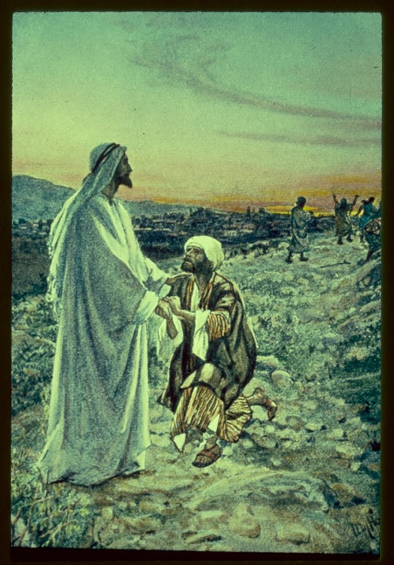

Gospel: Luke 17:11-19
As Jesus made his way to Jerusalem, he went along the border between Samaria and Galilee. He was going into a village when he was met by ten men suffering from a skin disease. They stood at a distance and shouted, “Jesus! Master! Take pity on us!”
Jesus saw them and said to them, “Go and let the priests examine you.”
On the way they were made clean. When one of them saw that he was healed, he came back, praising God in a loud voice. He threw himself to the ground at Jesus' feet and thanked him. The man was a Samaritan. Jesus said, “There were ten men who were healed; where are the other nine? Why is this foreigner the only one who came back to give thanks to God?” And Jesus said to him, “Get up and go; your faith has made you well.”
The Gospel of the Lord.
Praise to you Lord Jesus Christ.

