Sunday 2nd October
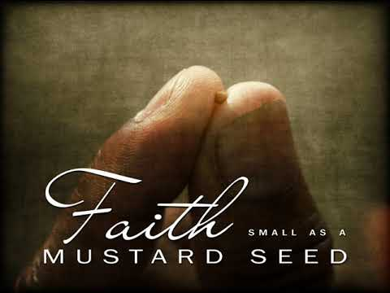

Gospel: Luke 17:5-10
The apostles said to the Lord, “Make our faith greater.”
The Lord answered, “If you had faith as big as a mustard seed, you could say to this mulberry tree, ‘Pull yourself up by the roots and plant yourself in the sea!’ and it would obey you.
“Suppose one of you has a servant who is ploughing or looking after the sheep. When he comes in from the field, do you tell him to hurry and eat his meal? Of course not! Instead, you say to him, ‘Get my supper ready, then put on your apron and wait on me while I eat and drink; after that you may have your meal.’ The servant does not deserve thanks for obeying orders, does he? It is the same with you; when you have done all you have been told to do, say, ‘We are ordinary servants; we have only done our duty.’”
The Gospel of the Lord
Praise to you Lord Jesus Christ.

