Sunday 9th October
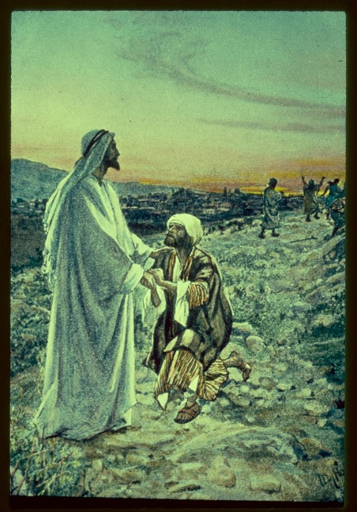

Let us show our thanks to God as we pray together:

We pray for the Church: that it may always be a place of healing love which welcomes all people. Lord in your mercy... Hear our prayer.

We pray for our brothers and sisters in every country, especially those who are ill or struggling to get enough food: that they may find comfort and support from those around them. Lord, in your mercy... Hear our prayer.

We pray for our parish, family and friends: that we may be moved to care for all people with tenderness and compassion. Lord in your mercy... Hear our prayer.

Loving Lord, help us to remember all the good things we have which come from you. Fill our hearts with thanks and praise. Help us to make sure all your people have their fair share of the gifts you give for us all. Amen.

