Prayers
Sunday 2nd October
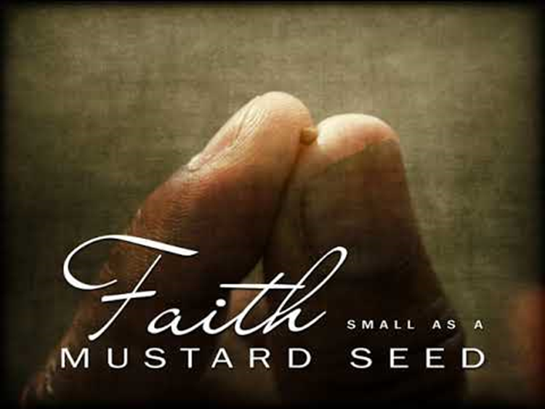

We know that everything is possible with faith and God’s help, and so we pray together:

We pray for world leaders: that they may see that real change is possible and act to make the world a fairer place for everyone to live. Lord, in your mercy…

We pray for all people throughout the world who do not have enough food or water: that they may have hope, faith and the support that they need, as they work to change their lives for the better. Lord, in your mercy…

We pray for our parish, family and friends: that we may have the faith and courage to try to make a real difference to our world so that it becomes a fairer place for all. Lord, in your mercy…

God of life, give us the courage to try to make a change to our world, no matter how small, and the faith to know that with you all things are possible. Amen.

