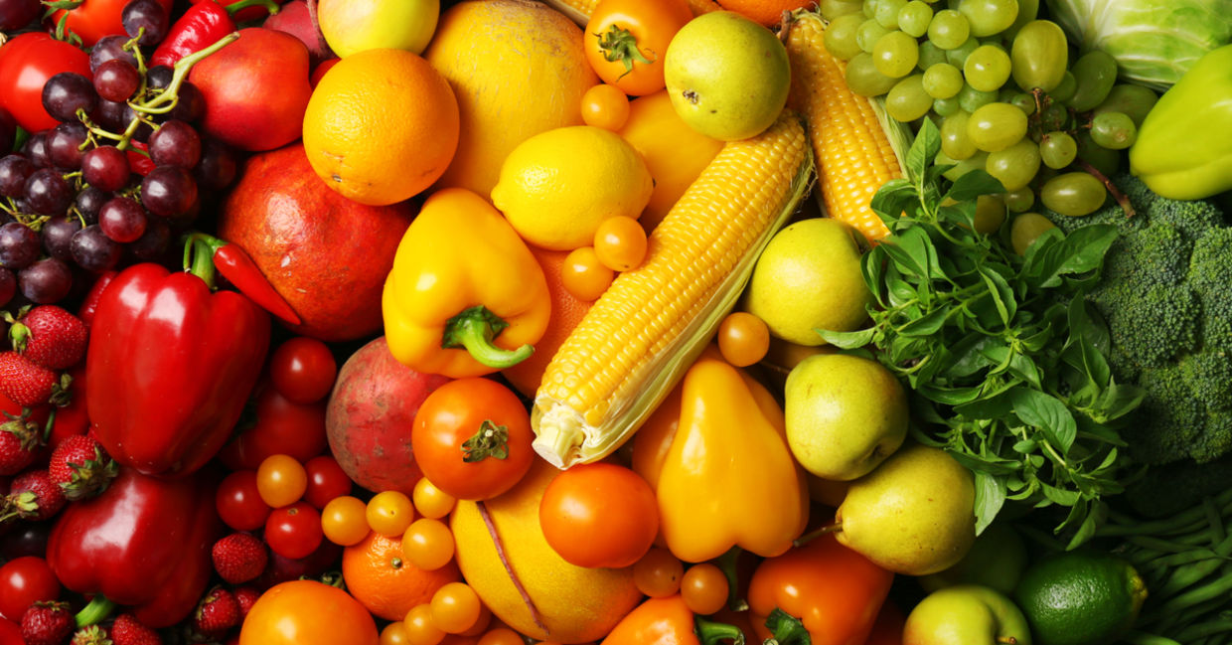

COMPUTING

We will be using Purple Mash to explore sequencing and coding.

We will continue to explore themes around online safety.

SCIENCE- SOUNDS

Year 3 will learn about keeping the human body healthy through nutrition and exercise.

We will look at skeletons in humans and other animals, understanding the names and functions of bones in the skeleton.

Music

We will be learning how to play and instrument with Mrs Fox and learning about notation.

Art and Design

We will be studying Claes Oldenburg’s textile food sculptures. We will be starting to record in our sketch books to make sketches of food in different medium.

We will then make 3D sculptures of foods.

**Healthy**

**Humans**

**YEAR 3**

Design and Technology

We will be designing healthy picnic food and a container to transport it in.

LITERACY

We will be reading and listening to fables from Michael Rosen’s version of Aesop’s Fables and writing our own fables.

We will then be looking at shape poetry and calligrams and creating our own poetry about movements.

Children will then write persuasive letters to children in another class encouraging them to eat healthily.

PE

We will be looking at the skills surrounding tag rugby- passing, position and scoring.

We will also begin to look at dance and explore movement.