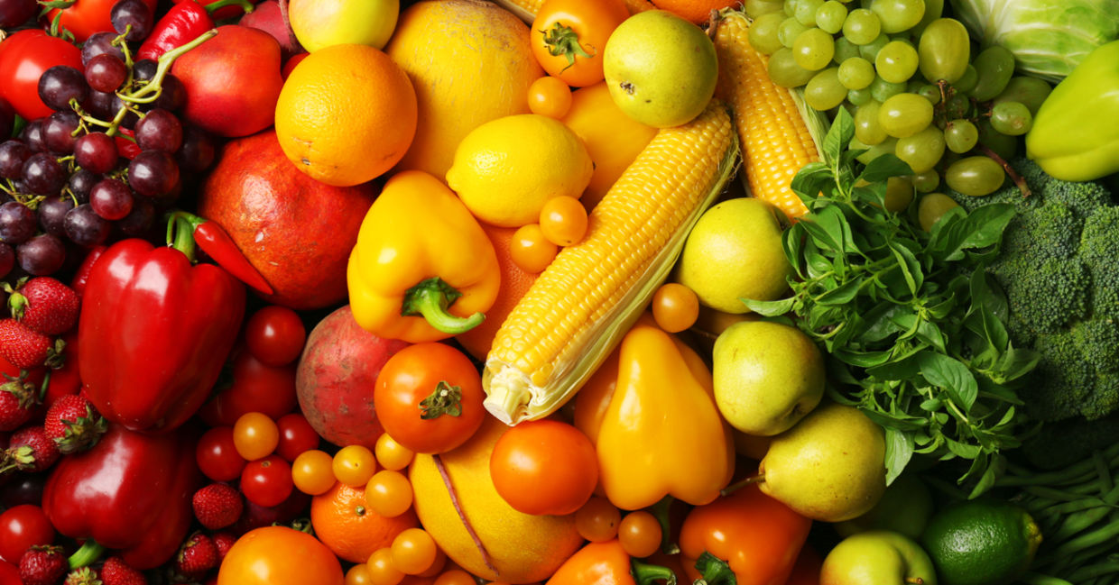

RE

synagogue Jesus

Torah visitor

kippah Christmas

tallit Advent

Judaism symbols

respect preparing

celebration coming

community gifts

rules giving

Art and Design

sketch medium

shape record

observe shade

density create

Music

play stave

listen crotchet

pitch quaver

volume clef

**Healthy**

**Humans**

**YEAR 3**

LITERACY

fable poetry persuade

character rhyme letter

narrative shape discuss

setting verse agree

determiner calligram disagree

a line reply

an imagery produce

COMPUTING

debug bullying

sequence appropriate

code sharing

game personal

delete information

PE

pass movement

pivot dance

score position

goal motif

defend music

Design and Technology

plan evaluate

design research

make net

bake transport

boil fresh

taste shape

SCIENCE- SOUNDS

exercise skeleton

diet skull

growth pelvis

energy ribs

protein bone

sleep vertebra

balanced movement

muscle joint

MATHS

ones equal =

tens more

hundreds less

multiply x increase

divide ÷ decrease