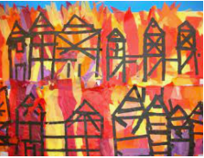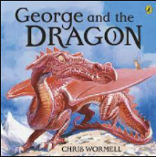

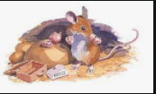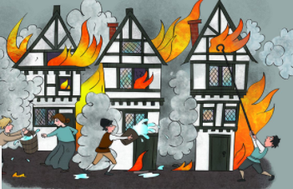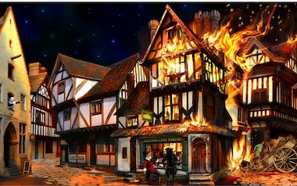

DESIGN TECHNOLOGY product – purpose – user – lever – slider - design – make – cut evaluate – template join – tear – fold – straight – curved

PE beat – curl – dance – fast – feet – high – low - music rhythm - step - stretch – swing – turn - twist – mood – feeling – theme – story - static – end - friendship – start middle – hit – send – roll - collect – stop – net - throw – strike – catch – bowl – feed - pick up – batter – hitter - forehand - backhand - court.

RE families – brother – sister – Mum – Dad – sharing caring – helping – psalm – home – house – happy – Mary – Joseph – Jesus – group – belonging – Baptism symbols – Chrism oil – font –white garment – shell - Priest – Godparents – candle – Easter candle – waiting – Advent – wreath – candles – Annunciation – Elizabeth – Nativity – Christingle- Christmas

**Fire! Fire!**

**Year 1**

Music listen – perform – duration – long – short - pitch – high – low - dynamics – loud – quiet - tempo – fast – slow – timbre – texture – round wood – metal – shaker – structure – same - different

ENGLISH sentence – full stop – capital letter – space - predict identify – discuss – text – pattern – repetition – rhymes – poems - self-correct – vocabulary – recall – information – punctuate – compose – events – suffixes – rehearse – orally – listen – follow – recite – opinion

COMPUTING instruction algorithm – computer – program - debug

left turn – right turn – backwards – forward – rewind - undo – direction challenge - arrow

SCIENCE Autumn – Winter seasons – weather – leaves – deciduous – evergreen – vein – stalk – observe – investigation – branch – trunk – twig – habitat – roots - stem

ART & DESIGN We will record and explore ideas from first hand observations and experiment with a variety of media. This will include drawing, painting and printing.

HISTORY past – present – old – new - young – days – months – before – after – a long time ago – same – different – source – chronological order

MATHS add - total – subtract – take away - fact family – part-whole model – equals – compare – difference – plus number bond – altogether – more - less number line