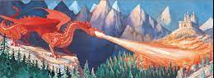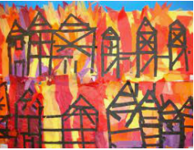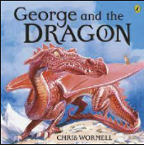

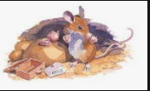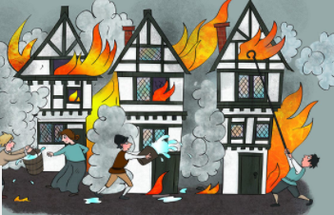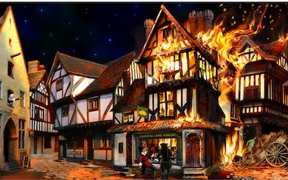

COMPUTING During our Lego Builders topic we will look at the importance of following instructions and how the order of instructions can affect the outcome. During our Maze Explorers topic, we will use directional keys to navigate different mazes.

SCIENCE We will continue to make observations of the changes that happen to the trees in our school grounds. We will learn about deciduous and evergreen trees and name and label the parts of a tree. We will compare leaves from different trees and learn about the changes that happen during Autumn and Winter.

DESIGN TECHNOLOGY We will explore books with moving parts to see how they have been made. We will then experiment with levers and sliders to explore ways to make things move in a 2D plane before making our own moving picture.

RE We will learn about Baptism in our Belonging topic. Then we will learn about Judaism as we look at the story of Abraham and Moses. During our Waiting topic we will learn more about Advent and the Christmas Story.

PE Our PE lessons this term will be Dance and Games: send and return.

Music We will learn the songs for our Christmas production and begin to learn how to play the ocarina. We will also listen to, appreciate and perform songs from a range of styles and genres based on the theme of fire.

MATHS We will complete our addition and subtraction to 10 unit this term. We will learn about the part whole model and learn number bonds for numbers up to 10. We will find fact families and develop our fluency when completing addition and subtraction questions.

ENGLISH We will write simple sentences using capital letters, spaces and full stops which can be read by ourselves, and others. We will continue to apply phonic knowledge for reading and spelling and continue to read and spell the Year 1 common exception words. We will recite poems and rhymes by heart and develop fluency, accuracy and confidence by re- reading books.

**Fire! Fire!**

**Year 1**

ART & DESIGN We will record and explore ideas from first hand observations and experiment with a variety of media. This will include drawing, painting and printing.

HISTORY During this topic we will learn about The Great Fire of London. We will find out about how it started, how long it lasted and how they eventually put the fire out. We will learn about some of the changes made after the fire and compare the fire service then to now.