


St Joseph’s Catholic Voluntary Academy SEND Information Report
Armadale Drive
Leicester
Leicestershire
LE51HF
0116 2416197



WITH GOD'S GUIDANCE WE LOVE, LEARN, RESPECT AND FORGIVE

Ethos, Values and Vision

Welcome to our 2022 / 2023 SEND Information Report which is part of the Leicester Local Offer for learners with Special Educational Needs and Disabilities (SEND). This Local Offer has been produced by the Local Authority (LA) in collaboration with Leicester City schools. All governing bodies of maintained schools and maintained nursery schools and the proprietors of academy schools have a legal duty to publish information on their website about the implementation of the governing body policy for pupils with SEND.

At St Joseph’s Catholic Voluntary Academy, we are committed to working together with all members of our school community. The children, staff and parents work actively in partnership to enable all children to realise their potential. Our school is an inclusive school where every child matters; we aim to address children’s needs and support their development in the most appropriate way possible and celebrate effort as much as achievement. Our school’s SEND policy document is available on this website, detailing our philosophy in relation to SEND.

What is in a SEND Information Report?

- The kinds of SEN that are provided for
- Policies for identifying children and young people with SEN and assessing their needs

- Arrangements for consulting parents of children with SEN and involving them in their child’s education

- Arrangements for consulting young people with SEN and involving them in their education

- Arrangements for assessing and reviewing children and young people’s progress towards outcomes.

- Arrangements for supporting children and young people in moving between phases of education and in preparing for adulthood.

- The approach to teaching children and young people with SEN

- How adaptations are made to the curriculum and the learning environment of children and young people with SEN

- The expertise and training of staff to support children and young people with SEN

- Evaluating the effectiveness of the provision made for children and young people with SEN

- How children and young people with SEN are enabled to engage in activities available with children and young people in the school who do not have SEN

- Support for improving emotional and social development.

- How the school involves other bodies, including health and social care bodies, local authority support services and voluntary sector organisations

- Arrangements for handling complaints from parents of children with SEN about the provision made at the school

WITH GOD'S GUIDANCE WE LOVE, LEARN, RESPECT AND FORGIVE
The Leicester Local Offer

The Leicester Local Offer gives children and young people with special educational needs or disabilities (SEND) and their families information about help and services in Leicestershire.

The Local Offer brings together in one place information about health, education and social care for:

- children and young people from birth to 25 years old who have a special educational need or disability (SEND)

- parents and carers of children with SEND

- professionals working in health, care and education

- providers of services for children and young people

You can access The Leicestershire Local Offer at http://families.leicester.gov.uk/local-offer/

WITH GOD'S GUIDANCE WE LOVE, LEARN, RESPECT AND FORGIVE

About us…

Mrs Clair Dedman - Head teacher: cdedman@st-josephs.leicester.sch.uk

Sinead O’Gorman – SENDCo / Assistant Head: sogorman@st-josephs.leicester.sch.uk
Mrs Rachel Abel - Assistant Head: rabel@st-josephs.leicsester.sch.uk
Ursula Herbert - Office Manager: office@stjosephs.leicester.sch.uk

Website: www.stjosephs.leics.sch.uk
Twitter - @StJoseLeicester
Age range 3 to 11

WITH GOD'S GUIDANCE WE LOVE, LEARN, RESPECT AND FORGIVE
SEND at St Josephs

Number of children in school - 236

Number of SEND pupils - 35
Number of pupils with EHCPs - 2

We make provision for ALL children including those who have significant learning difficulties and/or disabilities. We support children with…

Communicating and interacting ‐ for example, where children and young people have speech, language and communication difficulties which make it difficult for them to make sense of language or to understand how to communicate effectively and appropriately with others.

Cognition and learning ‐ for example, where children and young people learn at a slower pace than others their age, have difficulty in understanding parts of the curriculum, have difficulties with organisation and memory skills, or have a specific difficulty affecting one part of their learning performance such as in literacy or numeracy.

Social, emotional and mental health difficulties ‐ for example, where children and young people have difficulty in managing their relationships with other people, are withdrawn, or if they behave in ways that may hinder their and other children's learning, or that have an impact on their health and wellbeing.

Sensory and/or physical needs ‐ for example, children and young people with visual and/or hearing impairments or a physical need that means they must have additional ongoing support and equipment. Some children and young people may have SEN that covers more than one of these areas.

The new Primary National Curriculum (2014) states that, `teachers should take account of their duties under equal opportunities legislation that covers disability, ethnicity, gender, sexual identity, and religion or belief.’

At St Joseph's we are committed to offering an inclusive curriculum to ensure the best possible progress for all our pupils, whatever their needs or abilities.

WITH GOD'S GUIDANCE WE LOVE, LEARN, RESPECT AND FORGIVE
Quality first Teaching

‘Every Teacher is a Teacher of SEN’

Provision for children with SEND is a matter for the whole school. The governing body, the school’s Head teacher, the SENCO and all other members of staff, particularly class teachers and teaching assistants, have important day– to–day responsibilities. All children in school should be getting this as a part of excellent classroom practice when needed.

For your child this would mean:

-Teacher has the highest possible expectations for your child and all pupils in their class.
-Teaching is based on building on what your child already knows, can do and can understand.

-Different ways of teaching are in place so that your child is fully involved in learning in class.

-Specific strategies are in place to support your child to learn. Your child’s teacher will have carefully checked on your child’s progress and will have decided that your child has a gap in their understanding/learning and needs some extra support to help them make the best possible progress.

WITH GOD'S GUIDANCE WE LOVE, LEARN, RESPECT AND FORGIVE
What is SEND?

SEND stands for Special Educational Needs/Disabilities

Indicators of possible SENDs are…

- Not like progress of peers starting from baseline.
- Below previous rate of progress

- Attainment gap remains the same or widens between them and their peers
- They do not make adequate progress despite appropriate interventions and adjustments and good quality personalised teaching.

- Below expected rate of development (physically and mentally).
- A significant difference in learning styles.

- When a SpLD may be present.

If it is agreed by teachers, parents and the SENDCo then a child will be placed on our School SEND Register.

WITH GOD'S GUIDANCE WE LOVE, LEARN, RESPECT AND FORGIVE
Assessing and Identifying

- Teachers begin ‘Initial Concerns’ documents when they have a concern about a pupil’s progress, this is recorded by the class teachers and SENDCo and monitored.

- Teachers assess all pupils termly using Target Tracker (Year group Progression Steps).

- SENDCo along with the SLT, meet after assessment periods to identify groups who may require additional and/or different support. When children are identified as not making progress in spite of ‘High Quality Teaching’ a plan of action is agreed with the teacher and shared with parents.

- Children who have SEND are continuously tracked using the Assess, Plan, Do, Review Cycle every 6 to 10 weeks. This tracking is based on personal targets and monitored through their individual support plans.

- The school also uses other forms of assessment such as checklists, small step trackers, assessments from other professionals and personal assessments linked to each individual.

- Parents sometimes ask us to look more closely at their child’s learning. We take all parental requests seriously and strive to investigate them all. Frequently, the concern can be addressed by High Quality Teaching or some parental support. Otherwise, a graduated response is implemented by school. This may result in the child being placed on the SEND register and given special educational needs support (SENS). If a parent/carer has any concerns about their child having an additional need they should contact the class teacher, in the first instance, and if needed a meeting will be set up with the SENDCo.

WITH GOD'S GUIDANCE WE LOVE, LEARN, RESPECT AND FORGIVE

Partnership – Other Professionals

The SENDCo works closely with a variety of professionals.
This includes support from education, health and social care professionals such as;

- Complex Learning, Communication and Interaction Support Team
- Educational Psychologists
- SEMH Team
- Language and Communication team
- Speech Therapists
- Children’s Occupational Therapists
- The school will regularly communicate with health professionals including the schools nurse, GPs, occupational therapists and community paediatricians

In addition to the services provided by the LA (see above), you may wish to seek support form voluntary and charitable agencies including;
- ADHD Solutions
- SENDIASS (Special Educational Needs and Disabilities Information, Advice and Support Service)
- Early Help
- NSPCC

WITH GOD'S GUIDANCE WE LOVE, LEARN, RESPECT AND FORGIVE

Partnership - Communication

- Each class teacher has an open-door policy and is happy to communicate with parents on a regular basis.

- In many circumstances, SEND pupils have communication books.

- Teachers will meet SEND parents 3 times a year to share and discuss targets and next steps forward for pupils, one of these meets is also with the SENDCo.

- The SENDCo freely distributes her email address to SEND parents to ensure they always have a line of communication.

- The SENDCo has an open-door policy and is happy to communicate with parents on a regular basis.

WITH GOD'S GUIDANCE WE LOVE, LEARN, RESPECT AND FORGIVE

Support Plans 1
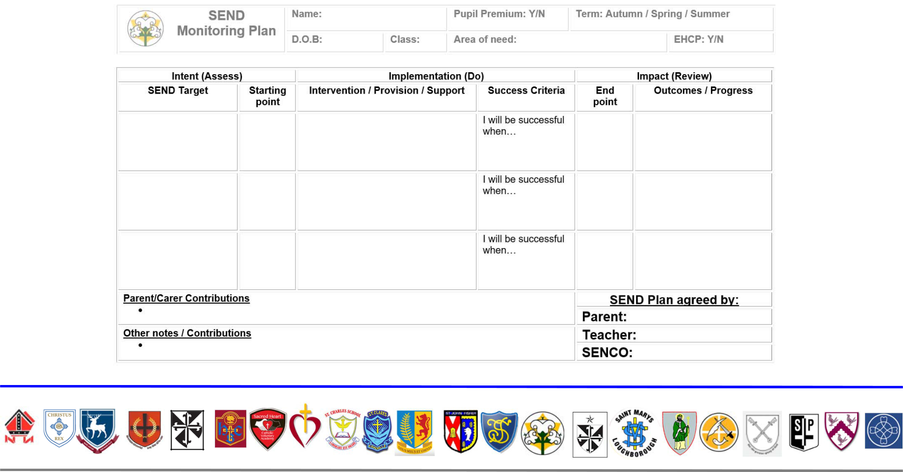

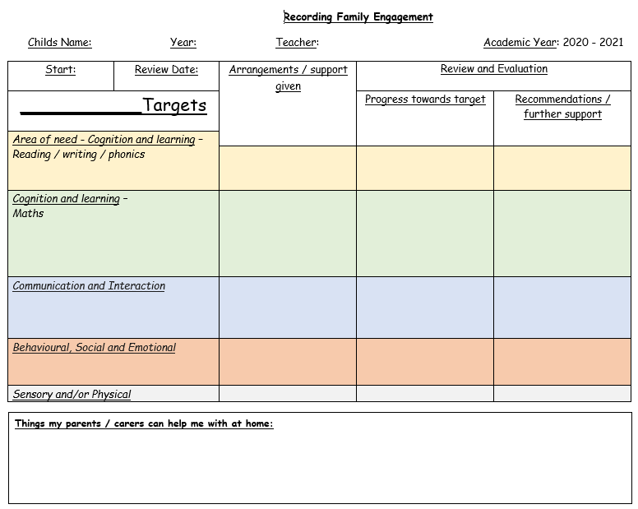

WITH GOD'S GUIDANCE WE LOVE, LEARN, RESPECT AND FORGIVE

Support Plans 2

We…

Assess every term - 6 to 10 weeks.

Plan next steps in collaboration with SENDCo, teachers, parents and pupils.

Do and implement agreed intervention and/or support.

Review at the end of the 6-to-10-week cycle to inform progress and impact.

Repeat the process again and improve/change practice, if applicable.

WITH GOD'S GUIDANCE WE LOVE, LEARN, RESPECT AND FORGIVE
Provisions and Interventions

Provision across the school varies from:

- One to one support

- Small group support

- Pre-teaching (intervention before whole class teaching) Proactive.

- Overlearning (teaching concepts repeatedly)

- Post-teaching (intervention after whole class teaching) Reactive.

- Immediate teaching/intervention (on the spot) during lessons.

- Precision Teaching (personalised teaching programmes).

- ELSA Support (Emotional Literacy Support)

- Speech and Language Therapy.

The majority of interventions and/or provisions are evidenced in pupil’s individual support plans and provision maps.

WITH GOD'S GUIDANCE WE LOVE, LEARN, RESPECT AND FORGIVE

Education, Health and Care Plans

- An EHCP is a legal plan which grants the pupil and family additional funding to help support their learning in school. Usually, the funding is given to schools to use and implement in the best way to support the individual.

- In order to obtain an EHCP, a school must demonstrate support for a pupil at or around £6000. Also, a pupil must meet certain criteria, this can be discussed with the school SENDCo in more detail,

- You can find more information about EHCPs from the school SENDCo or the Local Authority website….

- The school currently has 3 children with an EHCP.

WITH GOD'S GUIDANCE WE LOVE, LEARN, RESPECT AND FORGIVE

Emotional Literacy Support Assistant (ELSA)

At St Joseph’s we recognise that there will always be children facing life challenges that detract from their ability to engage with learning. As a result, some children will require greater support to increase their emotional literacy than others. We are pleased to offer the ELSA Program at St Josephs, an initiative developed and supported by Educational Psychologists. For more information, speak to the SENDCo or ELSA.

The ELSA at St Josephs is Miss Jodie Maxwell

WITH GOD'S GUIDANCE WE LOVE, LEARN, RESPECT AND FORGIVE

SEND & the Curriculum

- We recognise that children identified with SEND have strengths in a variety of subjects.

- It is our intent to ensure that barriers to learning are removed to ensure our SEND children succeed in the wider curriculum.
- Our curriculum is creative, imaginative and meets the needs of all pupils. Giving them transferable knowledge and skills for the next stage in their education.
- Teachers plan a range of cross curricular, differentiated activities to suit all learning styles and needs. The curriculum is usually delivered through a topic-based approach to make the children’s learning fun and exciting.
- All our children access the full National Curriculum, and we recognise achievement and expertise in all curricular areas. As part of normal class differentiation, curriculum content and ideas can be simplified and made more accessible by using visual, tactile and concrete resources

WITH GOD'S GUIDANCE WE LOVE, LEARN, RESPECT AND FORGIVE

Training and Expertise

- The SENCo has the National SENCO Award.

- We aim to keep all school staff up to date with relevant training and developments in relation to the needs of pupils with SEN.

- The SENCO attends relevant SEN courses, SENCo Network meetings (locally and within the MAT) and facilitates/signposts relevant SEN focused external training opportunities for all staff.

- Staff members responsible for the support of our SEN pupils have a developing subject knowledge provided by Class teachers, SENDCo or external agencies in the form of training and/or good practice modelling.

WITH GOD'S GUIDANCE WE LOVE, LEARN, RESPECT AND FORGIVE
Resources and Equipment

- Raised Desks and sensory cushions.

- Dyslexia friendly resources (e.g., book marks)

- Visual Aids

- Pencil grips and specially designed pencils and pens (Stabilo easi-grips)

- Sand timers.

- ICT – Laptops, iPads.

- Fine/Gross motor skills activities (sorting and threading, etc).

- A variety of paper resources.

WITH GOD'S GUIDANCE WE LOVE, LEARN, RESPECT AND FORGIVE

Transition

- One of the benefits of being a close, family orientated school is that children know most staff. Despite this, we still endeavour to ensure class teachers meet to discuss SEND pupils and that children have an opportunity to be taught by their new class teacher.

- Also, it is the little things that help children with SEND settle into a new class. E.g., where their new peg will be and where they will sit can all be agreed before the child steps foot into their new class.

- The SENDCo will endeavour to meet with your child’s secondary school SENDCo to ensure they fully understand your child’s needs.

- Additional transitioning is arranged as well as normal transition days for Secondary.

- If your child is due to transfer to a specialist provision, we will often facilitate transitioning by inviting your chosen secondary school to your child’s October Annual Review (EHCP only).

WITH GOD'S GUIDANCE WE LOVE, LEARN, RESPECT AND FORGIVE
Complaints

- First, speak with your class teacher.

- Second, speak to the SENDCo

- Thirdly, speak to a member of the SLT (Head/Deputy-Head Teacher)

- Finally, speak with the head of the governing body.

- You can find out more in the complaint’s procedure.

WITH GOD'S GUIDANCE WE LOVE, LEARN, RESPECT AND FORGIVE
Governing Body

The SEND Governor is the Governing Body's champion for Learners

with SEND and those with inclusion needs. He or she will support and challenge the school to ensure that no Learner is treated less favourably, denied opportunity or left behind because they have additional needs. The SEND governor for St Josephs is Mr David O’Brien.

The SEND governor and SENDCo work closely together and meet approximately once every term.

WITH GOD'S GUIDANCE WE LOVE, LEARN, RESPECT AND FORGIVE

Relevant Documentation

You may also be interested in…

- School SEND Policy

- Safeguarding policy

- Behaviour policy

- Accessibility Policy

- If any of the above are not accessible via our website, then please do not hesitate to request a paper copy.

WITH GOD'S GUIDANCE WE LOVE, LEARN, RESPECT AND FORGIVE

