Sunday 25th September
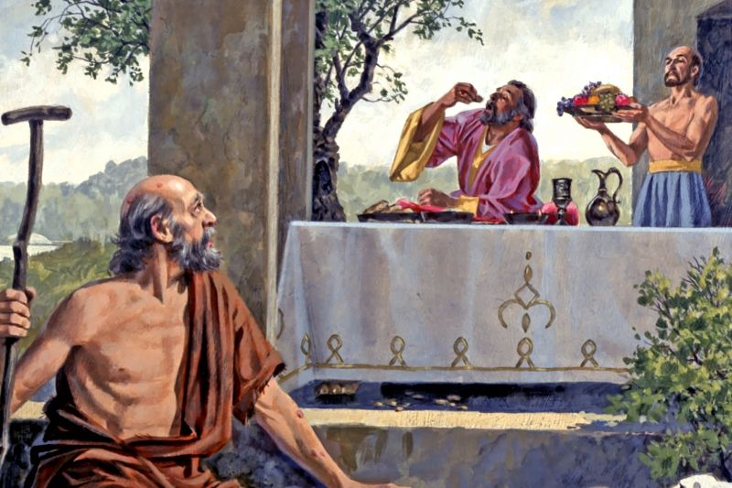

Gospel: Luke 16:19-31

“There was once a rich man who dressed in the most expensive clothes and lived in great luxury every day. There was also a poor man named Lazarus, covered with sores, who used to be brought to the rich man's door, hoping to eat the bits of food that fell from the rich man's table. Even the dogs would come and lick his sores.

The poor man died and was carried by the angels to sit beside Abraham at the feast in heaven. The rich man died and was buried, and in Hades, where he was in great pain, he looked up and saw Abraham, far away, with Lazarus at his side. So he called out, ‘Father Abraham! Take pity on me, and send Lazarus to dip his finger in some water and cool my tongue, because I am in great pain in this fire!’

But Abraham said, ‘Remember, my son, that in your lifetime you were given all the good things, while Lazarus got all the bad things. But now he is enjoying himself here, while you are in pain. Besides all that, there is a deep pit lying between us, so that those who want to cross over from here to you cannot do so, nor can anyone cross over to us from where you are.’ The rich man said, ‘Then I beg you, father Abraham, send Lazarus to my father's house, where I have five brothers. Let him go and warn them so that they, at least, will not come to this place of pain.’

Abraham said, ‘Your brothers have Moses and the prophets to warn them; your brothers should listen to what they say.’ The rich man answered, ‘That is not enough, father Abraham! But if someone were to rise from death and go to them, then they would turn from their sins.’ But Abraham said, ‘If they will not listen to Moses and the prophets, they will not be convinced even if someone were to rise from death.’”
The Gospel of the Lord

