Prayers
Sunday 25th September
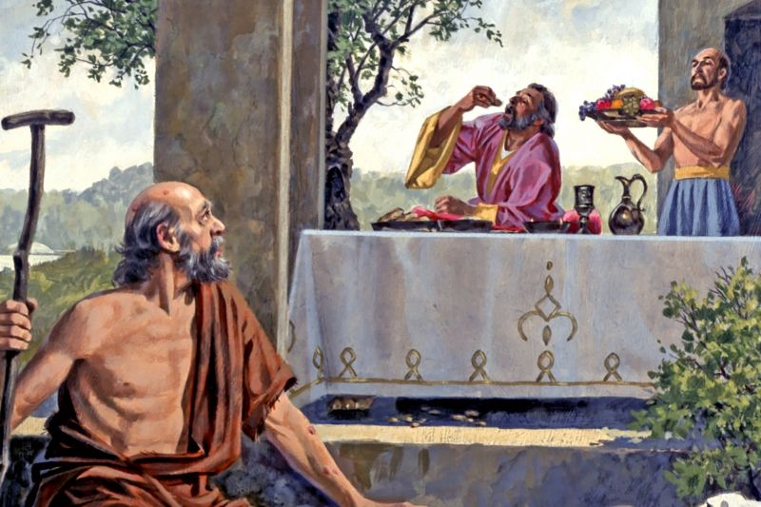

We are all God’s children and so we pray together:

We pray for world leaders: that they may make wise decisions for the good of all people, so that everyone may have enough to eat. Lord, in your mercy…

We pray for those who go hungry: that they may know that they are not forgotten and that together we can work so that all people have enough to eat. Lord in your mercy…

We pray for our parish, our family and our friends: that we may be moved to share what we can with our brothers and sisters here and around the world. Lord, in your mercy…

Generous God, you created the world with enough food for all to share. Help us to play our part in making sure that all people can have their fair share of food to eat. We ask this through Christ our Lord, Amen.

