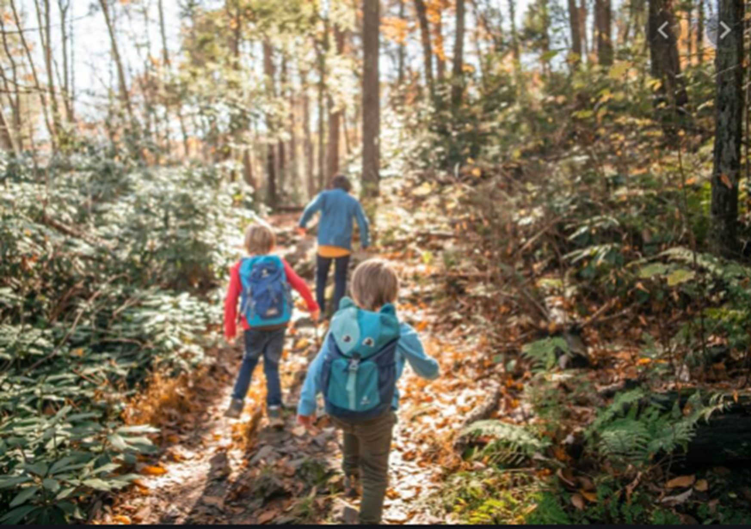

ENGLISH

We will be writing a narrative based on a story with a familiar setting, an information booklet and we will be learning and performing some traditional rhymes. We will be reading Goat and Donkey in the Great Outdoors, various information books and the following traditional rhymes: I’m a Little Teapot, Row, Row, Row Your Boat, Ring a Ring of Roses, and In and Out the Dusty Bluebells. We will use full stops and capital letters to start sentences and for names and places. We will identify and use exclamation marks and question marks and use the conjunction ‘and’ to join sentences.

MATHS

We will start with Fractions and will focus on finding halves and quarters. We will continue to consolidate our understanding of addition, subtraction, multiplication and division. We will also learn how to tell the time at o’clock and half past the hour. We will learn how to measure and compare the mass and capacity of different objects.

SCIENCE

In Year 1 we will be learning about everyday materials. We will learn how to distinguish between an object and the material from which it is made. We will identify and name a variety of everyday materials and describe their simple physical properties. We will also work scientifically by performing simple tests to explore questions.

PE

In our Run, Jump, Throw, topic we will take part in a broad range of opportunities to extend strength, balance, agility and coordination. We will cooperate with others to carry out more complex physical activities. In our Send and Return topic we will develop sending skills with a variety of balls. We will track, intercept and stop a variety of objects such as balls and beanbags. We will select and apply skills to beat the opposition. In our Hit, Catch, Run, topic we will develop sending and receiving skills to benefit fielding as a team. We will distinguish between the roles of batters and fielders. We will introduce the concept of simple tactics.

DESIGN TECHNOLOGY

During this topic we will develop a product for a story character, for example, a tower for Rapunzel, a chair for Baby Bear or a slide for a Lego character to slide down. We will design, make and then evaluate our product.

ART & DESIGN

We will learn about landscape artists. We will discuss and evaluate their work and begin to express our likes and dislikes about both the media used and the subject. We will use drawing and painting to develop our observational skills.

**THE GREAT OUTDOORS**

**YEAR 1**

RE

In our Being Sorry topic, we will think about the choices we make and how sometimes we choose well and how at other times we choose wrongly. We will learn about how God helps us to choose well and to be sorry and that God forgives us. We will listen to stories from the Bible about Levi and Zacchaeus and how Jesus helped these men to say sorry and make better choices. In our Neighbours topic we will learn about how everyone in the world is our neighbour and that we are all loved by God.

MUSIC

We will investigate and record sounds from our local environment. We will play listening games to help us to identify sounds in our environment. We will play various materials and structures in our environment and record these sounds. We will then use percussion instruments to try to recreate these sounds.

COMPUTING

During these lessons we will use code blocks to create a simple program.

GEOGRAPHY

We will learn simple fieldwork skills, including observation and recording, to study the geography of our school and its grounds. We will investigate the key human and physical features of our school’s surrounding environment. We will consider similarities and differences between our own school’s environment and others.