Sunday 8th May 2022
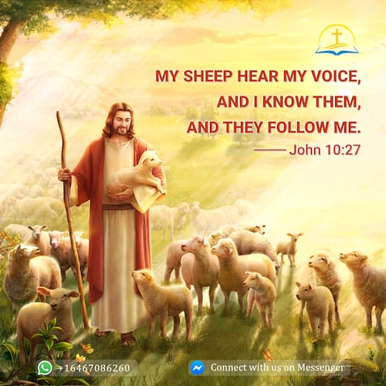

Gospel: John 10:27-30

My sheep listen to my voice; I know them, and they follow me. I give them eternal life, and they shall never die. No one can snatch them away from me. What my Father has given me is greater than everything, and no one can snatch them away from the Father's care. The Father and I are one.”

