Sunday 22nd May 2022
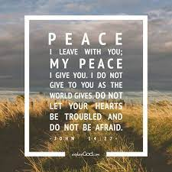

Gospel: John 14:23-29
Jesus said to his disciples:
“Whoever loves me will obey my teaching. My Father will love him, and my Father and I will come to him and live with him. Whoever does not love me does not obey my teaching. And the teaching you have heard is not mine, but comes from the Father, who sent me.
“I have told you this while I am still with you. The Helper, the Holy Spirit, whom the Father will send in my name, will teach you everything and make you remember all that I have told you.
“Peace is what I leave with you; it is my own peace that I give you. I do not give it as the world does. Do not be worried and upset; do not be afraid. You heard me say to you, ‘I am leaving, but I will come back to you.’ If you loved me, you would be glad that I am going to the Father; for he is greater than I. I have told you this now before it all happens, so that when it does happen, you will believe.”

