**Sunday 8th May 2022**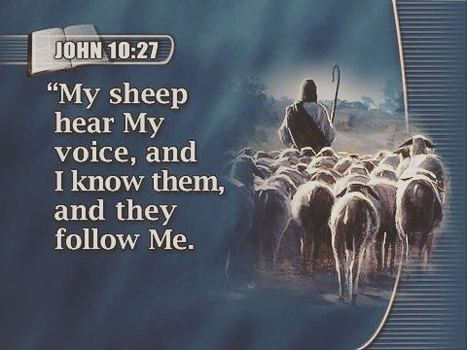

Let us pray together:



