Sunday 22nd May 2022

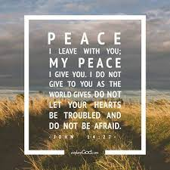

It is not always easy to live in peace with others, and so we pray together for God’s help:

We pray for world leaders: that they may do all that they can to make the world a peaceful place for everyone to live in. Lord, in your mercy…

We pray for all people around the world who live where there is fighting or war: that they may know peace. Lord, in your mercy…

We pray for our parish, family and friends: that we may do all that we can to share the gift of peace with others. Lord, in your mercy…

Living God, may we bring the light of your peace to those we meet. Help us to find a peaceful way to solve our problems, so that the world may be a safer place for everyone to live in. Amen.

