Sunday 1st May 2022
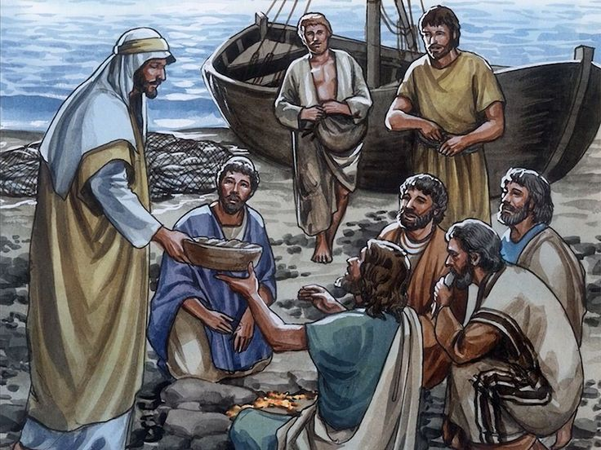

Let us pray together:

We pray for the Church throughout the world: that it may follow Jesus’ example and be a place of welcome for everyone. Lord, in your mercy...

We pray for all people throughout the world: that they may have enough food to eat and find comfort and support as they share food with others. Lord, in your mercy...

We pray for our parish, friends and family: that we may do what we can so all people may share in the food given by God to us all. Lord, in your mercy...

Creator God, you made a world of plenty with enough food for everyone. As we break bread together, fill us with your love and lead us to share whatever we are able. Amen.

