Sunday 15th May 2022
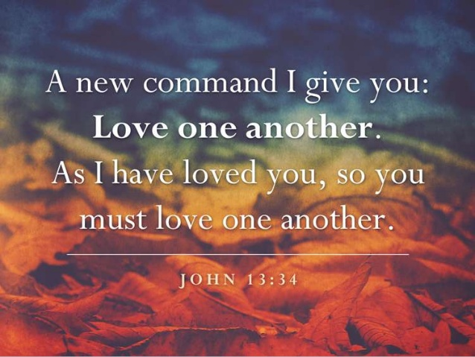
Let us pray together:
We pray for world leaders: that they may follow Jesus’s example and show special care for people who are poor, sick, alone or afraid. Lord, in your mercy…

We pray for all children around the world: that they may be loved and cared for and have hope for the future. Lord, in your mercy…

We pray for our parish, family and friends: that we may love one another as Jesus loves us. Lord, in your mercy…

Loving God, fill us with your love and help us to share this love with others, especially with those who are poor, sick, lonely or frightened. Amen.

