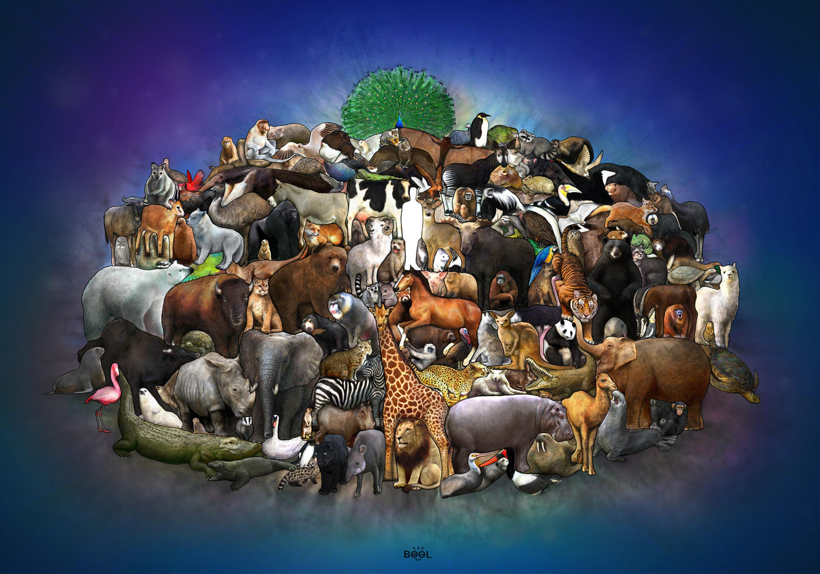

EXPRESSIVE ART AND DESIGN

Colour names

Shapes; circle – square – rectangle - triangle

Textures; rough – smooth – hard – soft - shiny

RE:

good news – share - Good News – Pentecost – promise - Holy Spirit – Easter – Alleluia - friend – happy – sad – love - make up – kind – gentle – loving - sorry – Jesus – forgive - change - rule – understanding - new start – friendship – forgive - change

LITERACY

Stories linked to animals will help to develop your child’s vocabulary

Dear Zoo

What the Ladybird heard.

The Lion Inside

The Squirrels who squabbled

Farmyard Hullabaloo

Whose Baby am I?

PHYSICAL DEVELOPMENT

Develop children’s independent dressing skills encouraging them to do more by themselves.

Support the children to hold the pencil in the correct grip.



During meal times discuss the importance of eating healthy foods and a balanced diet.

COMMUNICATION AND LANGUAGE

Encourage children to use the correct past, present and future tenses when speaking.

Games such as ‘What animal am I? to develop asking questions.

Talking about how to take care of own pets.

UNDERSTANDING THE WORLD

Farm – zoo – cow – pig – horse – goat – duck – chicken – giraffe – lion – elephant – baby names

MATHS

Maths stories to share

One Moose, 20 Mice, One to Ten and back again, One is a Snail, 10 is a Crab, Which one doesn’t belong.

The images on this website are

great for encouraging maths

reasoning

<https://wodb.ca/>

PERSONAL, SOCIAL AND EMOTIONAL DEVELOPMENT

Listening games such as ‘Simon Says’ or ‘Red Light, Green Light’ will support your child to listen to instructions. Draw pictures to explore how your child is feeling. Discuss how to make friends and what to do when they fall out with their friends.