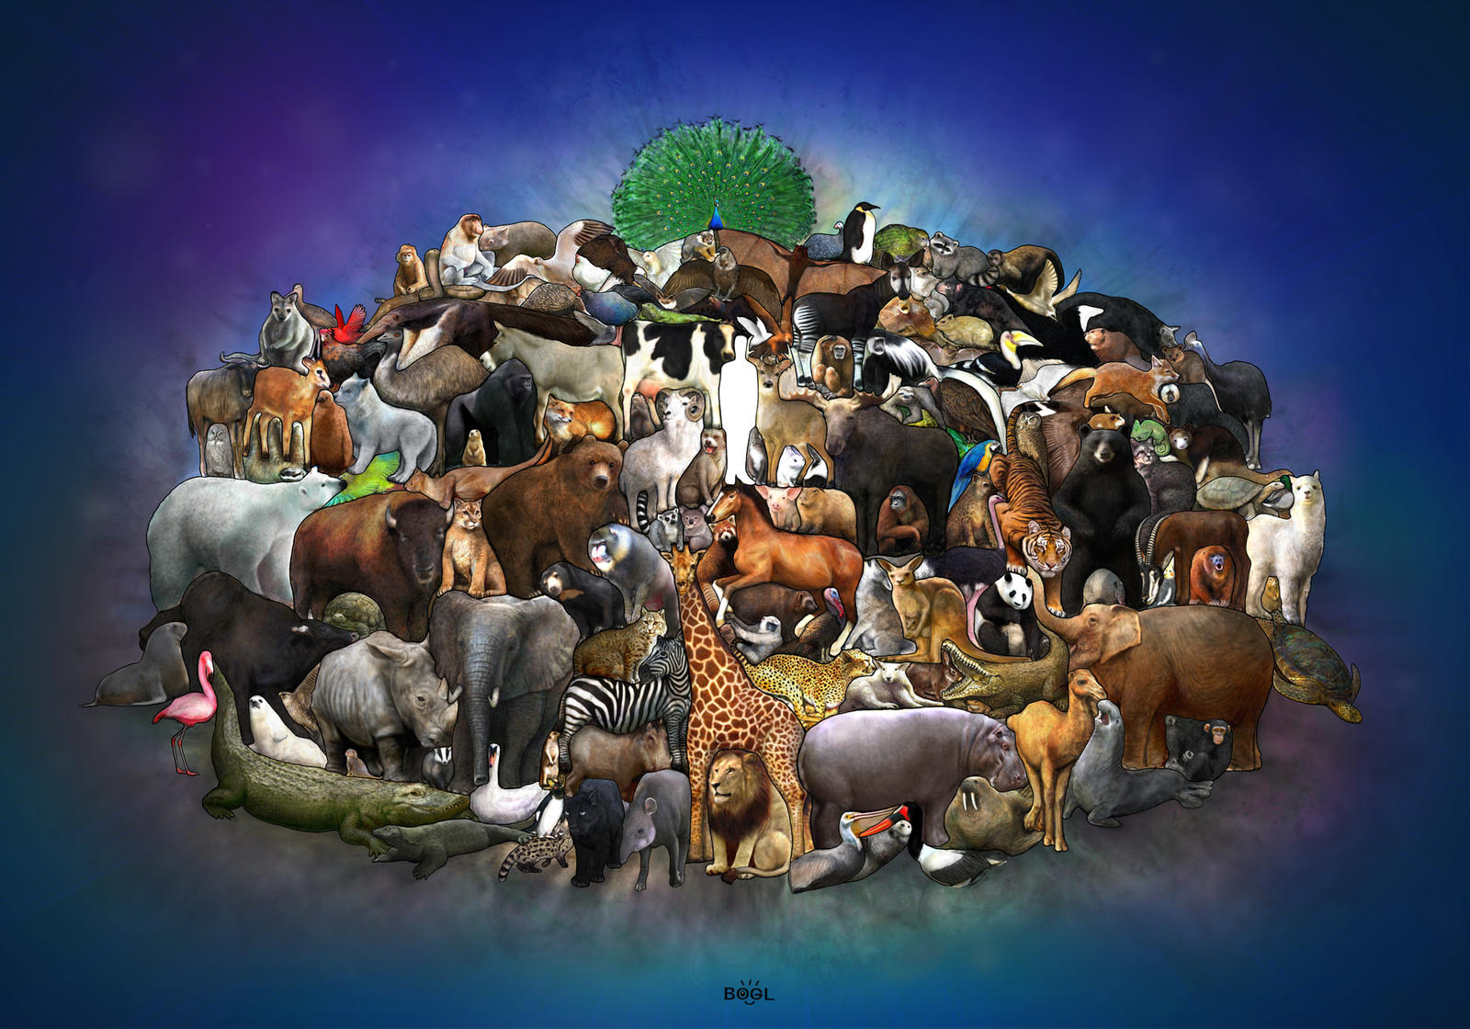

MATHS

Our focus will be counting to 20 forward and backward.

Finding one more and one less.

Ordering numbers to 20.

Adding more.

Taking away.

Spatial reasoning.

PHYSICAL DEVELOPMENT

Children will be challenged through a variety of gross and fine motor skills to improve their co-ordination, balance, strength, control and agility. Our focus is

We will be encouraging the children to develop independent dressing skills for our PE lessons.

We will focus on developing a good pencil grip.

**I wonder who lives there?**

UNDERSTANDING THE WORLD

Learn facts about different animals and their habitats.

To recognise animals that live in houses, the farm and in the wild.

LITERACY

The Jolly Postman, Dear Zoo, What do you do with a tail like this? What the Ladybird heard.

Based on these stories the children will be using their phonic knowledge to spell some words correctly and others that are phonetically plausible. In reading, they will use their phonic knowledge to decode regular words and read them aloud accurately.

COMMUNICATION AND LANGUAGE

We will encourage the children to talk about different animals in the wild and living on the farm. We will be developing our oracy skills by asking questions.

RE: We will share our good news and understand that everyone has good news to share. We will learn about Pentecost and the Good News about Jesus.

Islam: We will look at special items linked to the Islamic religion e.g. Prayer Mat, The Quran, Mosques

EXPRESSIVE ART AND DESIGN

We will be using different media forms to make our own models of a variety of animals and combining materials and textures to create artwork.

PERSONAL, SOCIAL AND EMOTIONAL DEVELOPMENT

We will focus on different relationships this term. We will begin with discussing relationships in our own families. We will then talk about our friends and how to be a good friend. We will think of ways to make friends and handle falling out with friends.