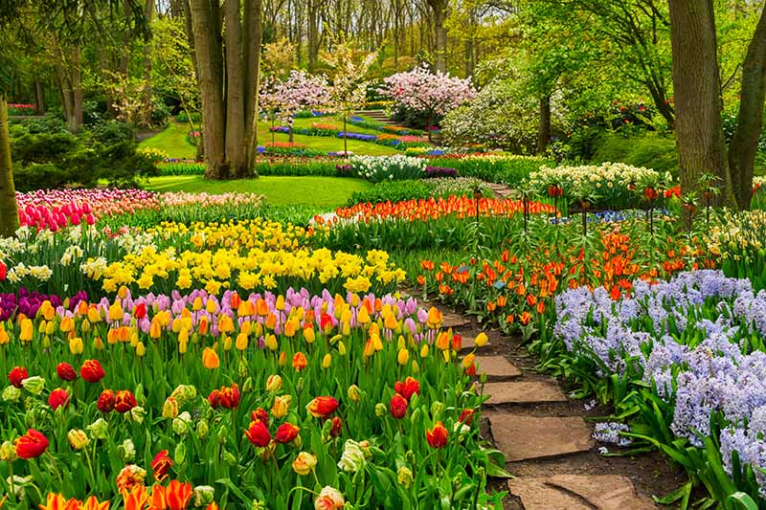

RE Guru Nanak – Gurmukhi - change – seasons – spring - growth – Lent - Ash Wednesday – opportunities Good Friday - Easter Sunday – alleluia – cross – resurrection – holiday – holyday – apostles – help – Pentecost – Holy Spirit – guide – promise <https://www.youtube.com/watch?v=KwJJJoSGw84>

ENGLISH VOCABULARY

character – setting – main events – full stop – capital letter sentence – exclamation mark – comma – apostrophe - suffix – root word - verb – imperative verb – instructions – fiction – non-fiction – traditional rhyme – poem – adjectives noun phrases - statement – command – question – exclamation

<https://www.bbc.co.uk/bitesize/topics/z8x6cj6/articles/z3dcmsg> <https://www.bbc.co.uk/bitesize/topics/z8x6cj6/articles/zcm3qhv>

MATHS

parts - whole – equal – half – quarter third – unit fractions – non-unit fractions – left – right – forwards – backwards – up – down – full turn – half turn – three quarter turn – clockwise – anti clockwise – pattern – position – o’clock – half past – quarter to – quarter past – minutes – hours - seconds

<https://whiterosemaths.com/>

PE attack – catch – compete – cooperate – defend – outwit - over-arm – pitch – receive – rolling – send – throw - under-arm – hit – collect – stop – net strike – bowl -feed - pick up batter – hitter –forehand – backhand – court – field - turn retrieve – dance - twist - beat rhythm - step - music - high stretch - feet - curl -low - fast slow – compose - choose – select emotions- canon - rhyme – theme – character – round – respond – swing.

SCIENCE VOCABULARY

observe – describe – seed – plant fruit – mature plant – grow – bulb –

healthy – reproduction – germination – vegetables – herb –

bedding plant – root – leaf – stem – flower – seedling – water – light – living – temperature – produce – leaves – twig – trunk – branch - weed

ART & DESIGN

media – observational drawing – mark-making - charcoal – pastels – felt tips – crayons – chalk – pencils – light – dark – line – motif – colour- print – printing block – tone – shade <https://www.bbc.co.uk/programmes/p0114xtq>

COMPUTING impressionism – palette share template – surrealism – pointillism bpm - instrument – soundtrack – composition - music –tempo – digitally – volume - sound effects (sfx)

<https://www.purplemash.com/sch/stjosephsle5>

DESIGN TECHNOLOGY

taste – smell – texture – sweet – crunchy – juicy – soft - fruit – vegetable – cut – grate – peel – chop – ingredients – peel – skin

<https://www.nhs.uk/change4life>