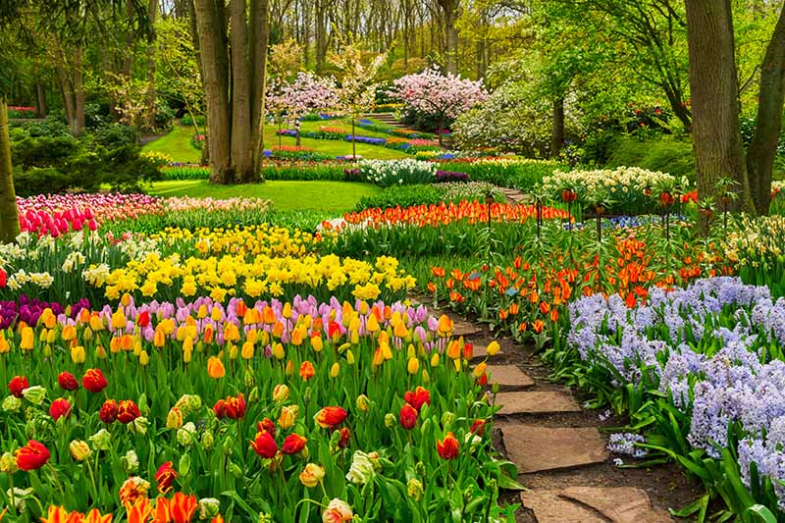

MATHS We will begin by learning about fractions and position and movement. We will then learn to tell the time at the quarter hour intervals and continue to consolidate our work on addition, subtraction, multiplication and division.

SCIENCE During these lessons we will observe and describe how seeds and bulbs grow into mature plants. We will also find out about and describe how plants need water, light and a suitable temperature to grow and stay healthy. We will also consolidate our prior learning about plants from Year 1.

ENGLISH

We will be writing a narrative, instructions and a poem based on a traditional rhyme. We will be reading The Empty Pot, a variety of instructional texts and traditional rhymes. We will add suffixes to root words, for example, -ed, –ing, -er, -est and identify and use exclamation marks and question marks.

ART & DESIGN

We will carry out observational drawings of leaves and flowers and make a simple print motif.

RE We will begin by learning about Sikhism. We will then begin our Opportunities topic where we will think about how we can change to become more like Jesus during Lent and then we will learn about the Easter story. After Easter we will learn about holidays and holydays and why these are important. We will also learn about what happened on Ascension Day and Pentecost and how we can live out the message of Pentecost.

COMPUTING We will look at the work of different artists during our Creating Pictures topic then move onto our Making Music topic where we will explore making music digitally.

DESIGN TECHNOLOGY During this topic we will design and make a healthy snack for a specific purpose, for example, fruit kebab for a barbecue desert, fruit salad for a birthday party or a vegetable pizza for a tea party.

**GROWTH AND GREEN FINGERS**

**YEAR 2**

PE We will select and apply a small range of simple tactics and recognise good quality in self and others. We will work with others to build basic attacking play. We will explore relationships through different dance formations and explain the importance of emotion and feeling in dance.