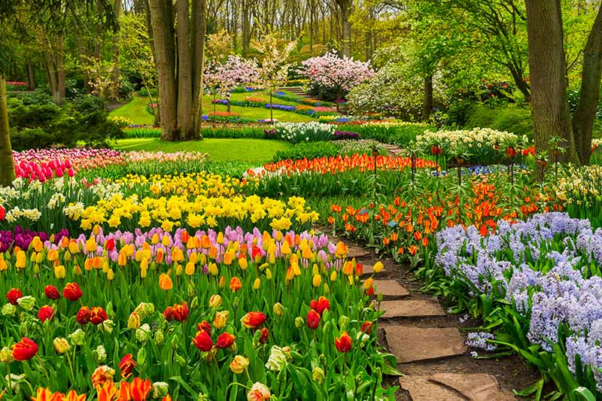

MATHS We will begin by learning about fractions and position and movement. We will then learn to tell the time at o’clock and half past the hour and look at Place Value to 100. We will also learn about mass and volume.

SCIENCE

Year 1 will be learning how to identify and name common wild and garden plants and deciduous and evergreen trees. We will also be learning how to identify and describe the structure of common flowering plants including trees.

ENGLISH

We will be writing a narrative, instructions and a poem based on a traditional rhyme. We will be reading The Empty Pot, a variety of instructional texts and traditional rhymes. We will add suffixes to root words, for example, -ed, –ing, -er, -est and identify and use exclamation marks and question marks.

PE We will begin to recognise and apply rules and simple strategies for invasion games. We will develop sending, tracking and intercepting skills and apply skills to beat the opposition. We will hit objects with a hand/bat and throw and catch a variety of balls and objects. We will build simple movement patterns from given actions Compose and link actions to make simple movement phrases.

RE We will begin by learning about Sikhism. We will then begin our Opportunities topic where we will think about how we can change to become more like Jesus during Lent and then we will learn about the Easter story. After Easter we will learn about holidays and holydays and why these are important. We will also learn about what happened on Ascension Day and Pentecost and how we can live out the message of Pentecost.

COMPUTING

We will be looking at how we can create and debug a set of instructions (algorithm) using a computer programme.

DESIGN TECHNOLOGY

During this topic we will design and make a healthy snack for a specific purpose, for example, fruit kebab for a barbecue desert, fruit salad for a birthday party or a vegetable pizza for a tea party.

**GROWTH AND GREEN FINGERS**

**YEAR 1**

ART & DESIGN

We will carry out observational drawings of leaves and flowers and make a simple print motif.