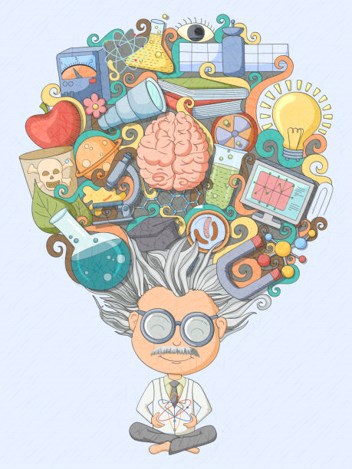

MATHS

Fraction, numerator, denominator, addition, subtraction, multiplication, improper fraction, mixed number, wholes, total, common denominator, simplify, partition.

LITERACY

Narrative, precise, vocabulary, paragraph, cohesion, active, passive, audience, purpose, effect, impact, subject, object, colon, semi-colon, explanation, scanning, skimming, opinion, justify, evaluate, edit, relative clauses, relative pronouns, inverted commas, verbs, dialogue, action.

PE

Lob shot, positioning, footwork, attacking, defensive, cannon, contrast, variation, facial expressions, contact, quality, confidence.

SCIENCE

Gravity, air resistance, water resistance, friction, surface, force, effect, move accelerate, decelerate, stop, change direction, brake, mechanism, pulley, gear, spring, theory of gravitation, Galileo Galilei, Isaac Newton, circuit, symbol, cell, battery, current, amps, voltage, resistance, electrons.

**Inventors and Inventions Year 5 and 6**

RE

Sikhism, sewa, witness, Easter, Crucifixion, resurrection, betrayed, Pentecost, disciple, Mardi Gras, Ash Wednesday, Easter Sunday, Jerusalem, Palm Sunday, salvation, wheat, Holy Spirit.

History

Islam, caliph, dynasty, scholar, calligraphy, vegetal, geometric, silk road, Baghdad, The House of Wisdom, inventions, inventor, trade, trade routes, art, Muslims, library, Arabic numbers, empire, education.

Design Technology

Mechanism, toys, model, rotary motion, linear, cams, shape, moving, materials, tools, evaluation, product, techniques.

COMPUTING

Properties, physical system, object, nesting, if, run, repeat, score, sequence, simplify, simulation, tab, timer, variable, coding, codes.