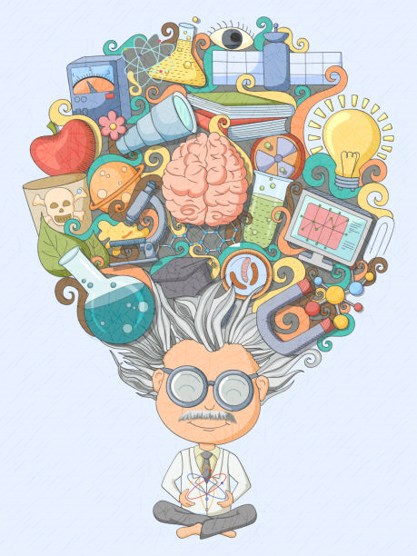

LITERACY

The term, the children will be writing a short story based on an invention. They will also be creating a page for a magazine which gives a range of information. The children’s main grammar focus will be using relative clauses with the correct relative pronouns to create complex sentences.

MATHS

In maths we will continue to work on fractions. We will be adding and subtracting fraction, multiplying fractions and finding fractions of amounts. We will then move on to fractions, decimals and percentages – recognising how they link together.

SCIENCE

Children will be looking at forces and electricity. They will begin by explaining that unsupported objects fall towards the earth because of the force of gravity. They will be able to identify the effects of air resistance, water resistance and friction, that act on moving surfaces. They will recognise that some levers, pulleys and gears, allow a smaller force to have a greater effect. The children will be able to associate the brightness of a lamp or the volume of a buzzer with the number and voltage of the cells used in the circuit. They will be able to compare and give reasons for variations in how components function, including the brightness of bulbs, the loudness of buzzers and the on/off position of switches. They will use recognised symbols when representing a simple circuit in a diagram.

**Inventors and Inventions Year 5 and 6**

RE

The children will begin by looking at Sikhism, Sacrifice and Witnesses. They will be looking at sacrifices we make during Lent and understand how Lent and Easter are important to Christians and how it shapes their lives. The children will deepen their understanding of the Easter Story and Pentecost. They will focus on the belief Christians have and how they can live out being a witness of God in their own lives.

History

In this theme, children are going to be learning about the Earl Islamic Civilisation. They will e locating Baghdad on a map, and making comparisons of the city over time. They will learn about the House of Wisdom, the role of a Caliph, the significance of trade at that time and the importance of geometric patterns.

Design Technology

This theme allows children to explore mechanical systems - cams, pulleys and gears. The children will investigate and evaluate everyday products or toys with moving am mechanisms. They will look at ways of strengthening structures for a moving toy. The children will design a moving toy with a cam mechanism and evaluate their finished design.

COMPUTING

The children will be using Purple Mash, following the Coding programme. The children will learn how to simplify a code and understand what a simulation is. They will understand how to use friction in a code and know what the different variable types are and how they are used differently. They will continue to develop the skills to identify risks involved with contact, content and their own conduct whilst online.

PE

Year 5 and 6 will be working on their dance skills and tennis.