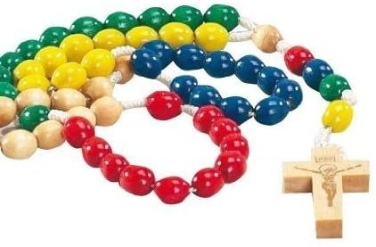
A Rosary
for children to pray for Ukraine and Russia.

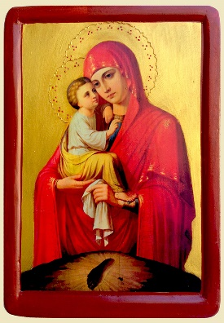
Let us start by praying an Our Father.

Hold one bead – Pray one Hail Mary – Our Lady of Ukraine, pray for us
Hold the next bead – Pray one Hail Mary – Our Lady of Ukraine, pray for us

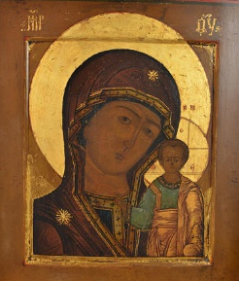
Hold the next bead – Pray one Hail Mary – Our Lady of Russia, pray for us
Hold the next bead – Pray one Hail Mary – Our Lady of Russia, pray for us

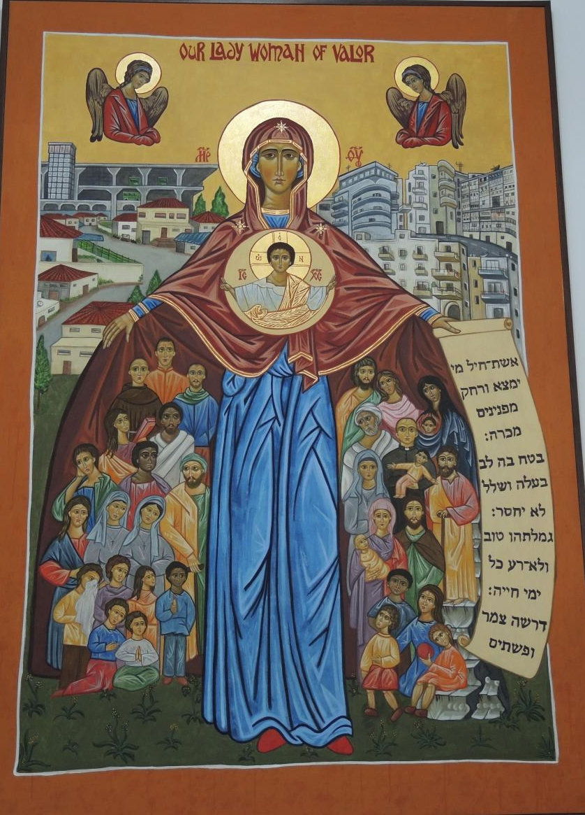
Hold the next bead – Pray one Hail Mary – Our Lady of Refugees, pray for us
Hold the next bead – Pray one Hail Mary – Our Lady of Refugees, pray for us

Hold the next bead- Pray one Hail mary – Our Lady of helpers, pray for us
Hold the next bead- Pray one Hail mary – Our Lady of helpers, pray for us

Hold the next bead- Pray one Hail Mary – Mary, Queen of Peace, pray for us
Hold the next bead- Pray one Hail Mary – Mary, Queen of Peace, pray for us

End by praying the Hail Mary together.

