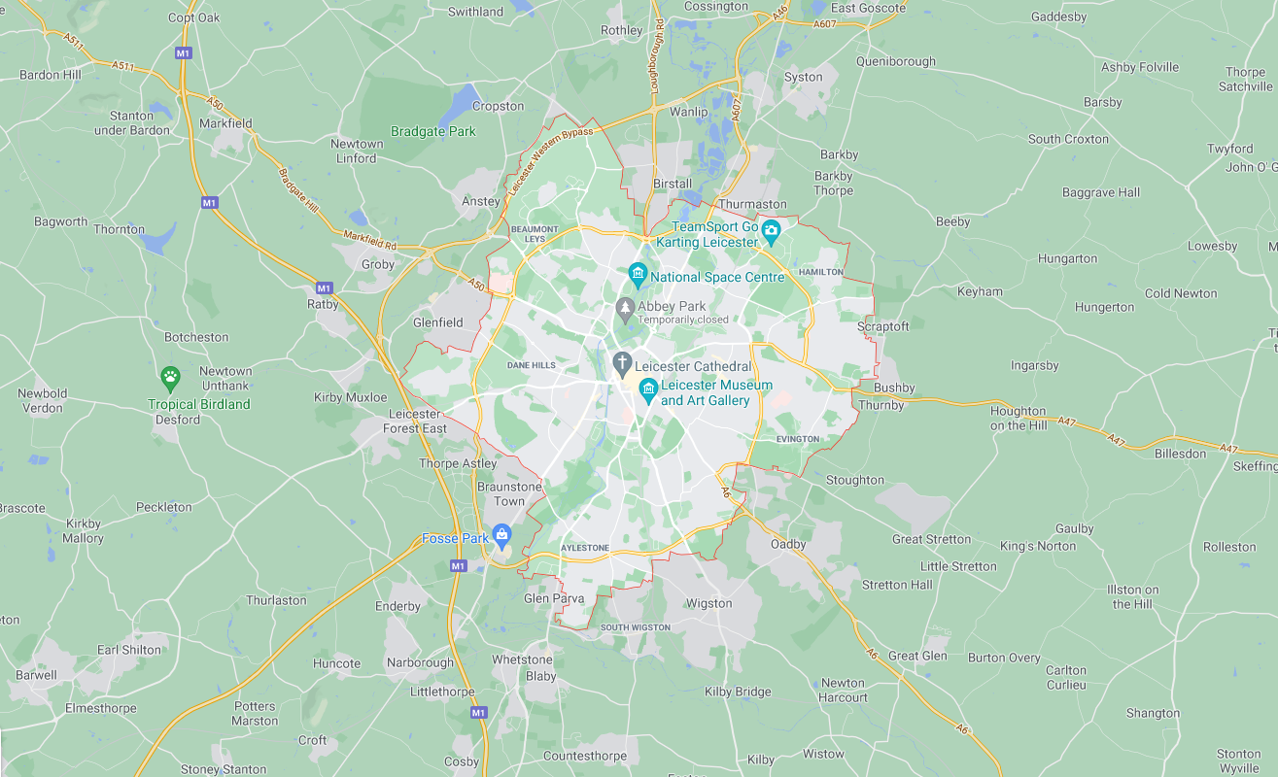

HISTORY

Local area- past- changed- over time- maps- digital maps-sources- games- equipment- Victorian- playground

MUSIC

Listen- music- feelings- recordings- chants- expression- volume- tempo- pitch- sounds- instruments- rhythm

RE

Beginnings- psalm- prayer- pray- world- God- creation story- signs- symbols- Baptism- white garment- candle- oil- priest- godparents

<https://www.bbc.co.uk/bitesize/clips/zm87tfr>

<https://www.youtube.com/watch?v=cZrwd7DgStA>

ART AND DESIGN

Observational- drawing- painting- rubbings- surfaces- landmarks- printing- motif- image- ink- repeated- pattern- evaluate

<https://www.bbc.co.uk/bitesize/topics/zkv39j6>

GEOGRAPHY

school grounds area- local- maps locate- landmarks- human features- physical features- aerial photos- key- symbols

PE

Start- finish- shapes- wide- narrow- level- high- low- medium- floor- standing- bend- movement- jump- control- tuck jump- high jump- bunny hop- balance- perform- transition- smooth- sequence- japana- bridge- split- straddle-spin- speeds- roll- left- right- inside- outside- kick- pass- receive- dribble- control- bounce- score- tackle- attack- defend- contact

COMPUTING

Bpm- instrument- soundtrack- composition- music- tempo- digitally- sound effects (Sfx)- volume

<https://www.purplemash.com/>

**The Place Where I Live- Year 2**

ENGLISH

story -narrative- texts- postcard – characters- events – sequence- subordination - subordinating clauses- conjunctions- nouns- adjectives- prediction- evidence- non-chronological report- poems

<https://www.bbc.co.uk/bitesize/subjects/zgkw2hv>

<https://www.theschoolrun.com/what-is-a-non-chronological-report>

MATHS

Counting- forwards- backwards- place value-tens- ones- compare numbers- numerals- words- objects- represent- addition- subtraction- compare- order- fact families-calculations- number sentences- number bonds- more- less- digit- crossing 10

<https://whiterosemaths.com/>

<https://www.bbc.co.uk/bitesize/subjects/zjxhfg8>

SCIENCE

nature- field- journals- observations- plants- animals -local environment