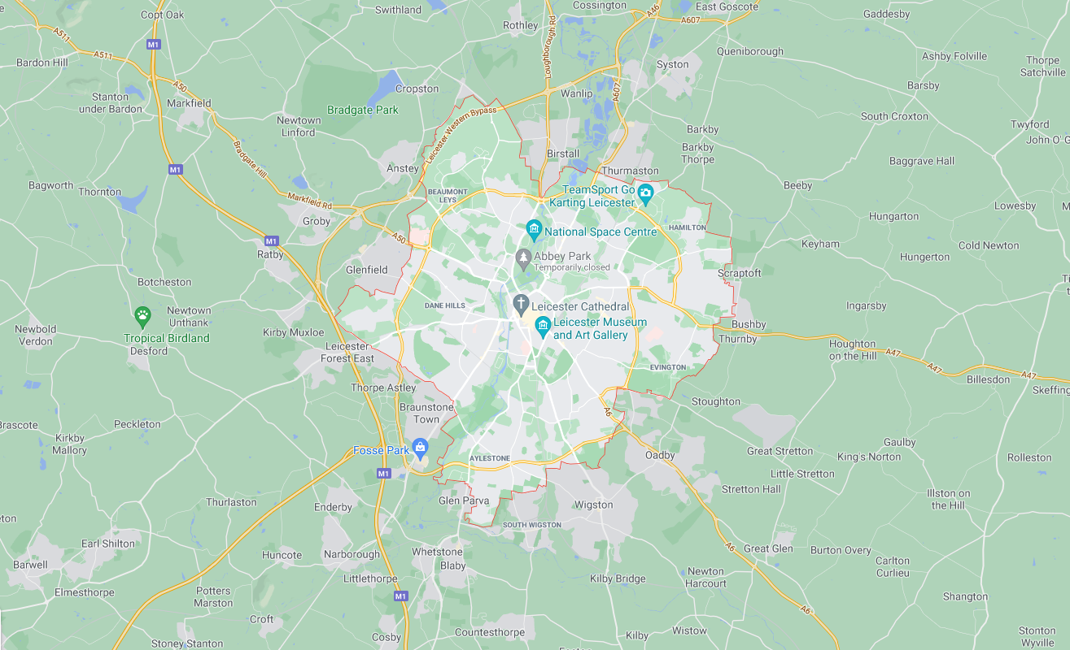

ART AND DESIGN

We will be making observational drawings and paintings of our school grounds and drawing local landmarks. We will then design and create a printing motif for our school or a local landmark that we have looked at and develop it into printmaking.

RE

In RE this half term we will be looking at new beginnings and focusing on prayers and the importance of them. We then move on to looking at the signs and symbols used during Baptism and the significance of them.

**The Place Where I Live- Year 2**

ENGLISH

We will be writing a story based on the book The Pirates Next Door by Jonny Duddle. We will also write a postcard from one of the characters to another. Our grammar focus will be looking at subordination and subordinating clauses. We then move onto writing our own non-chronological report where we will use some of the information learnt in history and geography. Lastly, we will be writing our own poem.

HISTORY

We will be focusing on the area where we live and taking a close look at what our school was like in the past and how it has changed over time.

MUSIC

Our focus for this topic will be on listening. We will experience how sounds can be made in different ways and create our own junk model instrument.

COMPUTING

We will be making our own music digitally. We will learn about different sounds and tunes and how music can be used to express feelings.

GEOGRAPHY

We will be looking at our school grounds and the area where we live. We will think about what our area is like and create maps of our area. We will use a variety of different maps to locate our school and recognise different landmarks and basic human features.

MATHS

Our focus will be on place value and working with numbers up to 100. We will then move onto adding and subtracting numbers.

SCIENCE

Our science focus for this topic is ongoing and will continue throughout the year. We will start by making our own nature and field journals where we will be making observations of plants and animals in their local environment and we will revisit these throughout the year.

PE

During this term our indoor PE session we focus on practising our gymnastics skills. In our outdoor session we will be learning and practising our attacking, defending and shooting skills in a variety of different sports.