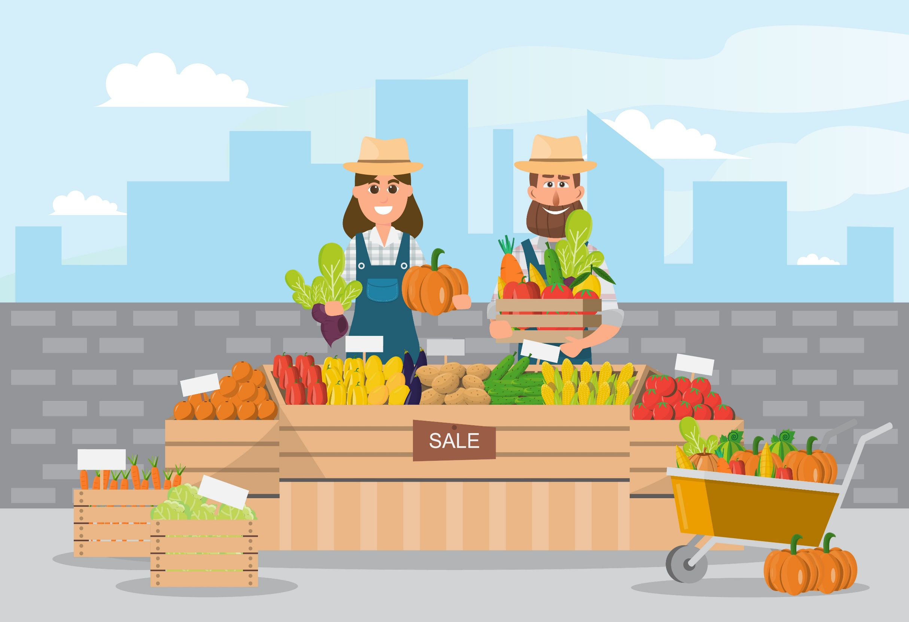

MATHS

In maths we will be focusing on properties of shape where we will look at 2D and 3D shapes. We then move onto fractions focusing on quarters, halves and thirds.

RE

In RE this half term we will be looking at ‘Opportunities’ and how life is full of opportunities for self-giving. We then move onto Sikhism focusing on how they pray and family life. Lastly, we move onto “Spreading the word” where we focus on the gifts of the Holy Spirit celebrated at Pentecost and how we spread the Good News.

MUSIC

In this unit we will improve our aural skills as well as singing abilities as we investigate traditional songs, musical elements and experiment with composing our own songs and lyrics.

DESIGN AND TECHNOLOGY

We will be exploring the eat well plate and make a seasonal salad looking at the health benefits. We will also think about the taste, smell, texture and feel of the ingredients.

Art and Design

Our art and design topic this term will focus on extensive drawing and painting using a range of fruit and vegetables. This will help us to develop and improve our observational skills.

ENGLISH

This term we will be looking at stories with familiar settings where we will write about a story set on a farm. We will then move onto writing a persuasive poster or leaflet persuading children to visit a farm or farm shop. Lastly, we will focus on riddles in poetry.

HISTORY

This half term we will be focusing on seaside’s and what we know about them and what they were like in the past. We will take a close look at Victorian seaside resorts and compare them to seaside resorts today.

PE

During this term our indoor PE session will focus on practising our dance skills. In our outdoor session we will be learning and practising our attacking, defending and shooting skills.

COMPUTING

In computing this half term, we will be looking at spreadsheets and learning how they work. We then move onto looking at different ways of presenting our ideas using a variety of software.

SCIENCE

Our science focus for this topic is plant growth. We will observe and describe how seeds and bulbs grow into mature plants. We will find out and describe how plants need water, light and a suitable temperature to grow and stay healthy (and how changing these affects the plant). We will know that plants are living things and eventually die.

The Farm Shop