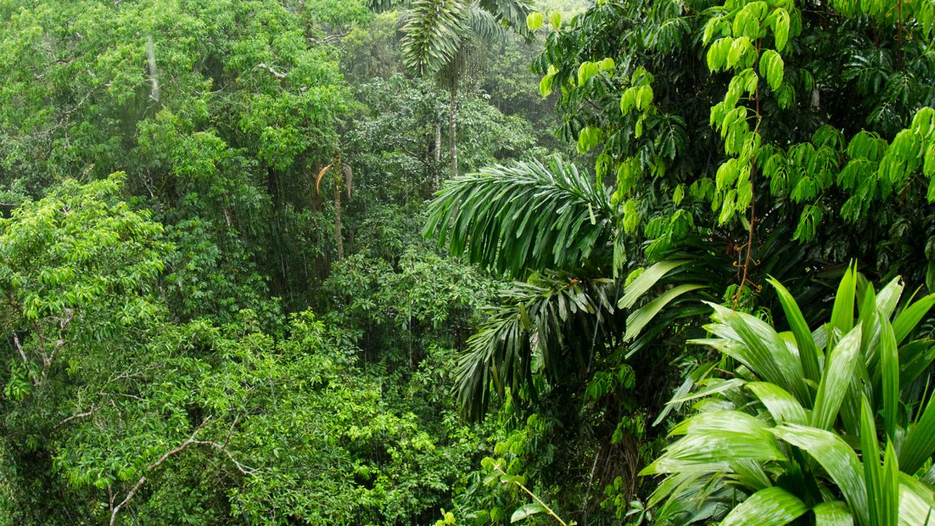

RE

Love, unconditional, Prodigal Son, commitment, vocation, Ordination, sacrament, link, scripture, Baptism, tolerance, hymn, prayer, giving.

<https://comeandsee.cafod.org.uk/Year-6-resources>

**SURVIVAL**

**YEAR 6**

GEOGRAPHY

Continent, country, ocean, human, physical, biome, vegetation, volcano, population, climate change.

<https://kids.nationalgeographic.com/>

<https://www.bbc.co.uk/bitesize/subjects/zbkw2hv>

MATHS

Number, place value, rounding, negative, addition, subtraction, worth, borrow, carry, more than, less, fewer, greater, multiply, divide, share, times.

<https://whiterosemaths.com/>

ART & DESIGN

Camouflage, sketch, import, pattern, repeat, rotate, graphics, annotate, colour.

<https://www.thoughtco.com/camouflage-129662>

PE

Chest pass, bounce pass, shoulder pass, move, pivot, space, shoot, defend, attack, travel, jump, balance.

<https://kids.kiddle.co/Netball>

COMPUTING

Search engine, accuracy, reliability, safety, plagiarism, copywrite, domain, fact, opinion, bookmarks, favourite.

<https://www.purplemash.com/>

SCIENCE

Darwin, characteristic, inherited, acquired, adaption, evolution, environment, habitat, species.

<https://www.thenakedscientists.com/>

<https://www.bbc.co.uk/programmes/p09cvs92>

LITERACY

Biography, paragraph, fronted adverbial, cohesion, comma, chronological, past tense, third person, novel, adventure, synonym, antonym, speech, character, adverbials of time.

<https://www.bbc.co.uk/bitesize/topics/zhrrd2p>