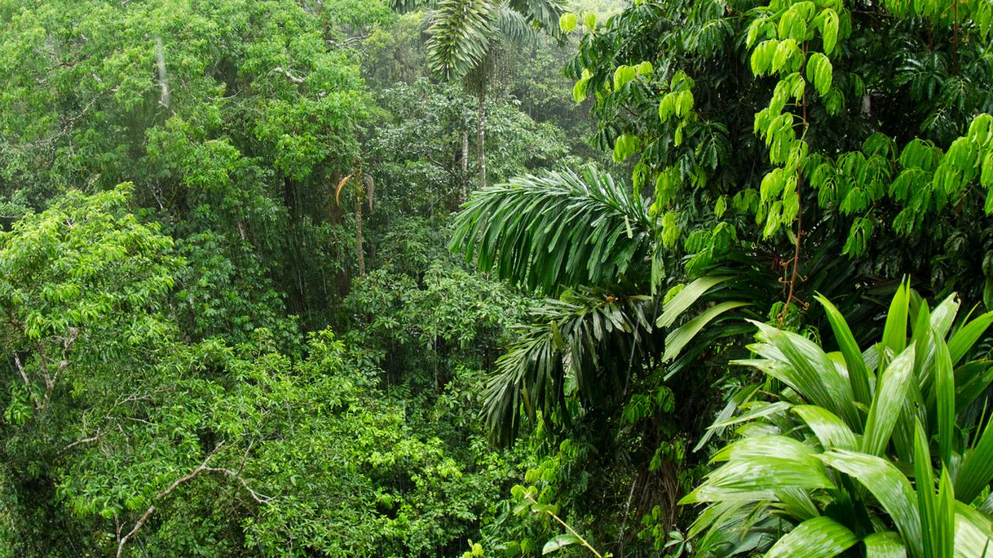

GEOGRAPHY

Year 6 will be using maps to explore the human and physical features of the world. They will research countries and weather patterns

COMPUTING

The children will be using technology to research information which supports our science, geography and English topics. The children will learn about search engines and how to question the content and reliability of websites they discover.

RE

‘Loving’ and ‘Vocation & Commitment’ will be the focus of this topic. The children will explore the idea of unconditional love and commitment. They will also look at how people are called by God to be priests and the sacrament of Ordination.

**SURVIVAL**

**YEAR 6**

PE

Year 6 will be practicing gymnastics and netball. They will also revisit dance, using a range of dance crazes as a stimulus.

MATHS

Our focus will be on number and place value. We will be revising and working on the four main operations – addition, subtraction, multiplication and division.

SCIENCE

Year 6 will be learning about evolution and Darwin’s theory. They will investigate how animals and plants have adapted to suit their environments and how characteristics can be inherited or acquired.

LITERACY

First, Year 6 will be researching, writing and presenting a biography. We will use a novel as a stimulus to plan, draft and write our own adventure stories.

We will be revisiting areas of grammar previously taught and looking at active and passive voice, subject and object and how to manipulate sentences.

ART & DESIGN

As part of our topic, we will be exploring camouflage and repeating patterns. We will experiment with various mediums and create a final piece using our favourite.