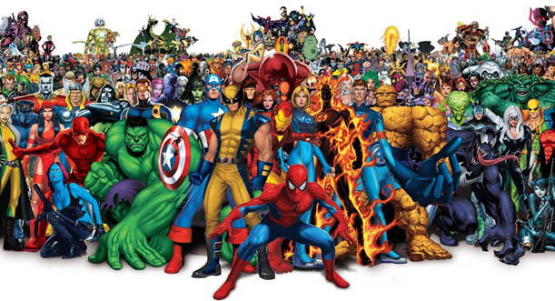

PE

Year 6 will be working on their football skills and improving their dance skill from the last unit of work.

RE

Sources is our topic for this half term. We will explore the Bible in depth and look at how it is structured, alongside reading and analysing scripture and psalms.

MATHS

Our focus will be fractions, decimals and percentages. We will look at algebra and how to use a simple formula to solve problems. We will also explore area and perimeter and how to calculate these, find the volume of shapes and explore ratio and proportion.

COMPUTING

The children will be using coding to create their own games.

**HEROES & VILLAINS**

**YEAR 6**

DESIGN TECHNOLOGY

As part of our topic, we will explore the work of Jamie Oliver and how he transformed school meals. We will design and make our own well-balanced meal.

ART & DESIGN

As part of our topic, we will be exploring portraits and the work of Pablo Picasso. We will explore different techniques and mediums and create our own ‘Picasso’ portrait.

MUSIC

Our focus for this topic will be The Wizard of Oz. We will listen to songs from ‘Wicked’ the musical and compare the heroes and villains in the musical.

SCIENCE

Year 6 will be learning about the function of the heart, lungs and circulatory system this term. We will also investigate the effect of exercise, diet and drugs and alcohol on our bodies.

LITERACY

We will be writing a narrative, an information text and a poem, alongside revisiting other genres this term. We will be using Shakespeare’s ‘Macbeth’, various information texts and poems by Ted Hughes. The grammar focus will be selecting appropriate vocabulary, manipulating sentences and bullet points and colons.