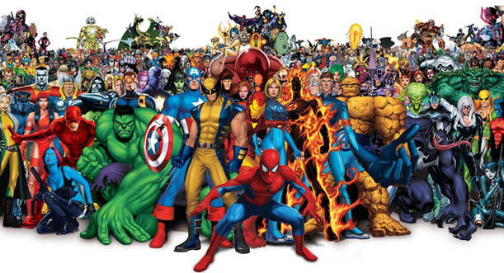

PE

Football – dance – phase – synchronisation – narrative – tension – contact – tackle – defend – attack – assist – strategy – covering

LITERACY VOCABULARY

Macbeth – Banquo – thane – hail –heath –phantom - emotive language – simile – metaphor – synonym – antonym – bullet point – colon – parenthesis – cohesion – relative clause

MATHS

decimal – percentage – fraction – area – perimeter – multiply – equation – algebra – rule – formulae – integer – rule – pairs – values – centimetre – millimetre -kilometre

RE

Source – Bible – scripture - Old Testament - New Testament -Bible reference - Dead Sea Scrolls - Holy Spirit - Paul, Torah – Judaism - Jewish.

COMPUTING

Program – debug – variable – input – output - algorithm – code - game

ART & DESIGN

Portrait – Pablo Picasso – cubism – surrealism – impressionist – proportion – medium

MUSIC

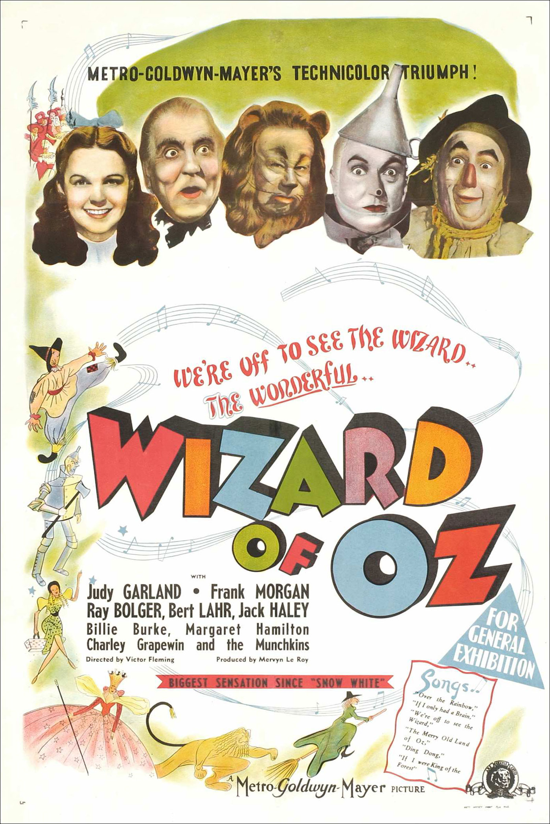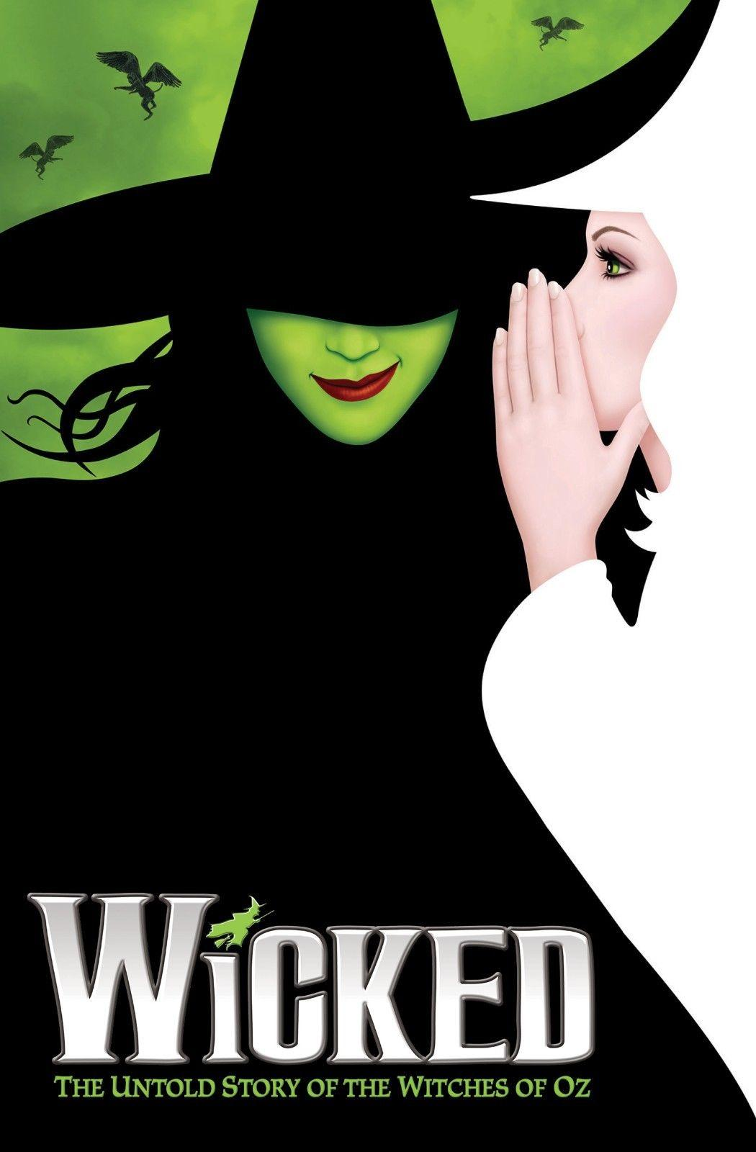

Verse – chorus – soprano – lyrics – diction – performance

DESIGN TECHNOLOGY

Recipe – balanced meal – dairy – meat – vegetables – minerals – carbohydrate – fibre – protein – vitamins – fats - sugar

SCIENCE VOCABULARY

Drug – alcohol – nutrient – oxygenated blood – deoxygenated blood – blood vessels – heart – circulatory system – veins – arteries – capillaries – plasma – white & red blood cells