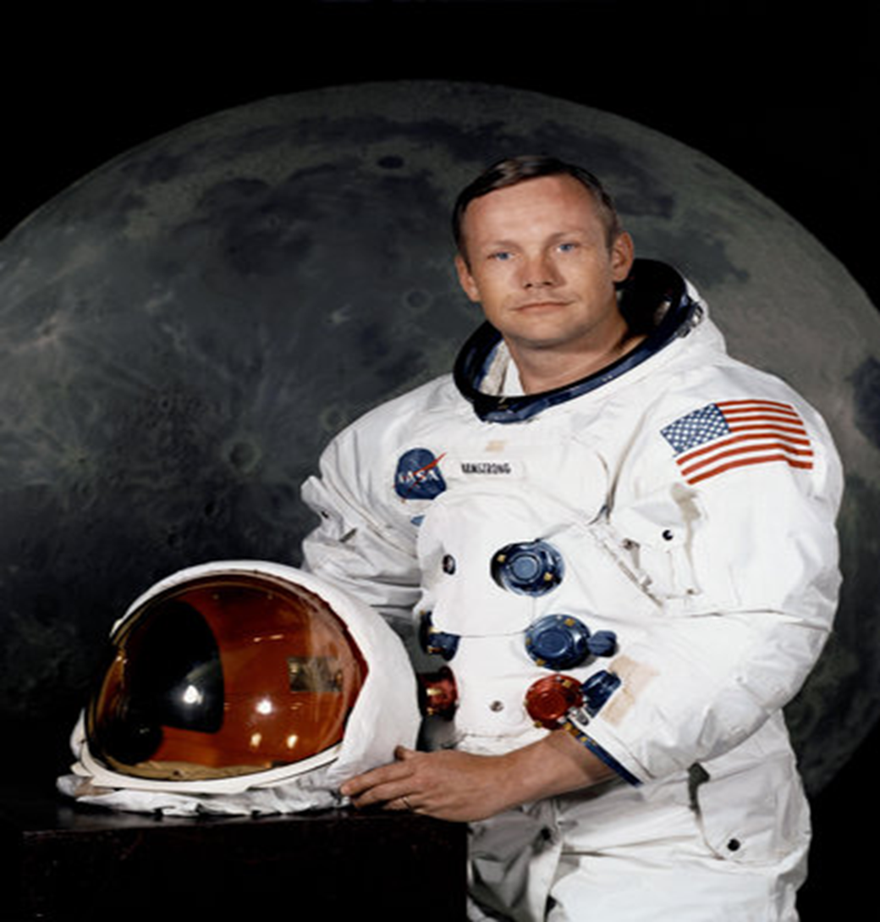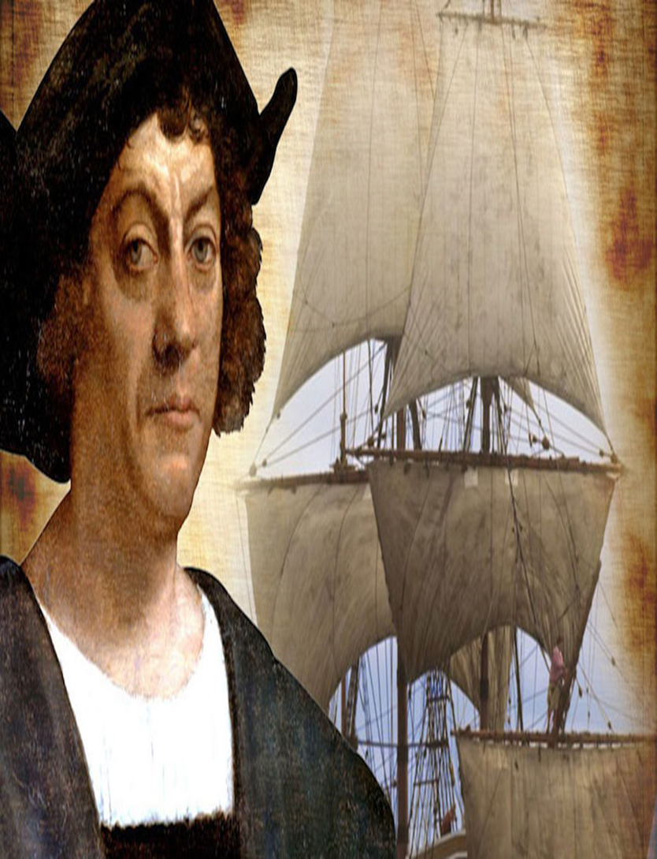

DESIGN AND TECHNOLOGY

Product- purpose- user – mechanism – moving – wheels – axle –chassis – vehicle – travel – terrain – materials – evaluate

MATHS

Equal – groups – make – add – recognise – multiplication – x symbol – multiplication sentences - arrays – doubles – times tables – sharing – grouping – divide – odd – even – tally chart – pictograms- interpret – diagram

GEOGRAPHY

Europe – non-European- country- continent - area- similarities- differences – explore - location - physical features - human features – maps – globes – atlases - Northern / Southern hemisphere – weather – seasons – river – settlement – shops – services – industry

SCIENCE

Materials- properties- wood- metal- plastic- glass- brick- water- rock- paper- cardboard- uses- soft – hard – bumpy - rough - smooth –shiny – dull –flexible –stretch-squash- bend- sort – classify – observe – testing – fair test – object

ENGLISH

Story – sequence - main events – apostrophes – contraction – subordination – time connectives- past tense – fiction – conjunctions – reason – present tense – predictions – characters – non – chronological – report – features – punctuation

COMPUTING

action- computer- programming- algorithm- button- background- collision detection – debug- debugging- design mode- event- key pressed- nesting- object- predict- properties- run- scale- scene- sequence- sound- test- text- timer- when clicked/ swiped

HISTORY

Similarities - differences- Neil Armstrong- past – present- explorer- equipment- spaceship- spacesuit- Christopher Colombus- journey- voyage

Explorers

PE

Run- throw- handle- power- quick – burpee- obstacle- control – stamina – static- dynamic- collect- body tension- control – carry – extension- fast- hang – timing- travel – turn – transition- smooth

MUSIC

Instruments – rehearse – perform – sounds – percussion –

everyday objects – pitch- low – high – dull – piercing – muddy – light – short – long – rhythms – fast – slow – tempo

RE

Books- Scripture- lectern- Gospel- Bible- New Testament- Old Testament- genre- thurible- missal- Church- parish family-thank you- thanksgiving- thoughtful –Eucharist- Eucharistic prayer