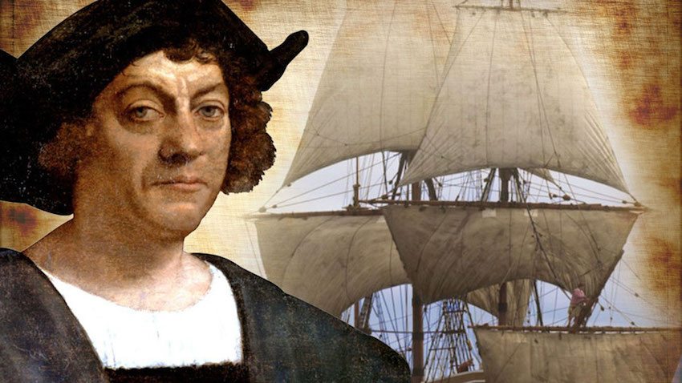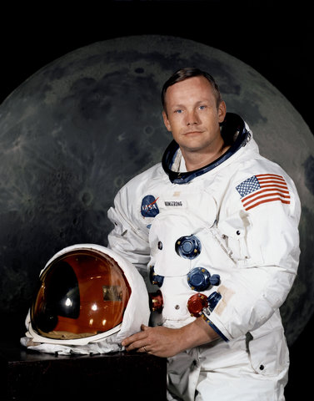

COMPUTING

We will be looking at computer programming and understanding what algorithms are and how they work. We will also look at finding any bugs (errors) in the programs and make sure they work correctly. We will do this by debugging them.

Explorers

HISTORY

This half term we will be focusing on explorers and we will look at where they went and what they did. We will also look at the equipment that they used and think about how this helped them on their journey.

PE

During this term our indoor PE session will focus on practising our gymnastics skills. In our outdoor session we will be learning and practising our running, jumping and throwing skills.

DESIGN AND TECHNOLOGY

We will be exploring moving mechanisms and making our own moving vehicle. We will follow the process of design, create and then evaluate our model.

MUSIC

In this theme, children are going to become ‘Everyday Explorers’ to explore the various sounds that be created using percussion and everyday objects.

RE

In RE this half term we will be looking at ‘Books’ and why we need books. We then move onto Thanksgiving and why we should be grateful for people.

GEOGRAPHY

In this topic we will learn about a small area within a contrasting non-European country (Cuba). We will explore similarities and differences between Cuba and areas with which they are more familiar- this builds on the knowledge, and understanding from The Place Where I Live.

MATHS

In maths we will continue to look at multiplication and division. We will work on multiplying and dividing by 2,5 and 10 and build on our understanding of odd and even numbers.

ENGLISH

This term we will be looking at stories by the same author. We will look at another Jonny Duddle book and write our own story based on the story. We then move onto non-chronological reports where we will write our own non- chronological report about explorers.

SCIENCE

Our science focus for this topic is looking at different materials and understanding their properties and uses. We will do this by designing and opening a mini museum near the seaside all about materials.