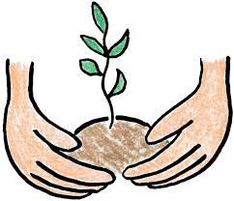

**I wonder how plants grow?**

LITERACY

Supertato, Oliver’s vegetables, Jack and the Beanstalk, Titch

Based on these stories the children will be using their phonic knowledge to spell some words correctly and others that are phonetically plausible. In reading, they will use their phonic knowledge to decode regular words and read them aloud accurately.

PHYSICAL DEVELOPMENT

Children will take part in PE lessons and explore what happens to their bodies when they are active and show understanding of the need for safety when tackling new challenges and consider and manage some risks.

We will develop our fine motor skills by exploring seeds and beans and using simple tools to pick them up.

COMMUNICATION AND LANGAUGE

We will be exploring plants and animals. The children will develop their own narratives and explanations by connecting ideas or events. They will answer ‘how’ and ‘why’ questions about experiences and in response to stories.

UNDERSTANDING THE WORLD

Making observations of plants and animals

Explaining why some things occur.

Talk about changes observed.

EXPRESSIVE ART AND DESIGN

We will be using different media forms to make observational drawings and

exploring famous art work of plants and flowers.

MATHS

Our focus will be on counting to 9 and 10 (forward and backward) and representing 9 and 10 in different ways, beginning to see smaller numbers within larger numbers.

Naming some 3d shapes.

Creating and designing patterns.

PERSONAL, SOCIAL AND EMOTIONAL DEVELOPMENT

Children will develop their confidence to speak in a familiar

group and say why they like some activities more than

others. They will be learning to take turns and decide how to organise activities

RE

We will be looking for signs of Spring and new life. We will learn that Lent is a time to grow in love to be more like Jesus and to look forward to Easter.