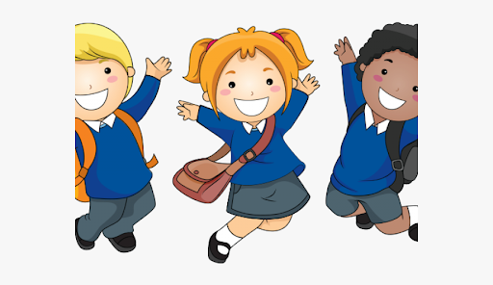

PHYSICAL DEVELOPMENT

Develop children’s independent dressing skills encouraging them to do more by themselves.

Discuss the language of movement, up – down, side to side, over, under, upside down.

Encourage children to use a variety of small tools independently such as forks, spoons and knives and scissors

EXPRESSIVE ART AND DESIGN

Colour names of hair and eyes

Shapes; circle – square – rectangle – triangle

RE: *Myself* myself, name, Christian, first name, family name, class name, precious, parent, God, love, loving parent, prayer *Welcome*: , belong, school, class, Baptism, baptise, water, candle, family, godparent, font, priest

UNDERSTANDING THE WORLD We will be making lots of new friends. Know some of the things that make us unique. Talk about some of the similarities and differences about their own and others families

LITERACY

Stories about ourselves and our families will help to develop children’s vocabulary

Elmer,

Once There Were Giants,

The Button Box,

We’re going on a Bear Hunt

Shine

COMMUNICATION AND LANGUAGE

Talk about your own family. Children may forget some of what they did at school. Ask them what pudding they had or what story they heard.

MATHS

Maths stories to share

Monkey Puzzle, Noah’s Ark, A Squash and a Squeeze, The Enormous Turnip, Where’s My Teddy, Mr Big.

This website encourages children

to spot differences.

<https://wodb.ca/>

PERSONAL, SOCIAL AND EMOTIONAL DEVELOPMENT

Listening games such as ‘Simon Says’ or ‘Red Light, Green Light’ will support your child to listen to instructions. Draw pictures to explore how your child is feeling. Discuss who to ask for help when they need it.

**I wonder what is**

**special about me?**