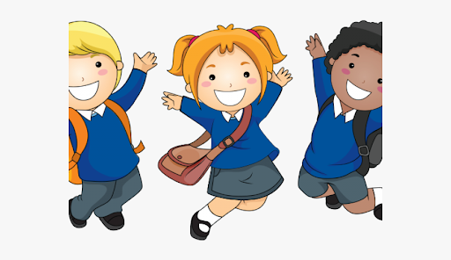

PHYSICAL DEVELOPMENT

Daily activities to improve our gross and fine motor skills including threading, cutting, weaving, playdough

Moving objects with good fine motor skills. Draw lines and circles using gross motor movements. Hold pencil/paint brush beyond whole hand grasp. Taking our shoes off and putting them on

EXPRESSIVE ART AND DESIGN

We will be exploring a wide range of media and experiment with making different marks. Drawing ourselves and creating family artwork

RE: Domestic Church – Family: Myself Children will be learning: The importance of my name, God knows and loves me and each one by name. Baptism/Confirmation: Belonging – Welcome: The children will be learning; What it is to welcome and be welcomed and that Baptism is a welcome to God’s family

UNDERSTANDING THE WORLD We will be making lots of new friends. Know some of the things that make us unique. Talk about some of the similarities and differences about their own and others families

LITERACY

Elmer, Once There Were Giants, The Button Box, We’re going on a Bear Hunt

We will be listening to stories and practising our good listening. We will talk about what we have heard and discuss the story together. Children will be learning the set 1 sounds and beginning to form these letters.

COMMUNICATION AND LANGUAGE

We will be talking about ourselves and what we like and dislike. We will learn about different kinds of families and see how they compare to our own. We will practise following instructions and listening carefully.

MATHS

Our focus will be counting carefully to 5.

Matching and sorting

Making comparisons of small numbers, capacity and length

Making simple patterns

PERSONAL, SOCIAL AND EMOTIONAL DEVELOPMENT

We will be talking about what makes each of us special, special people at home and people who can help us at school. We will be naming different feelings and discussing what we can do when we feel ‘not-so-good.’

**I wonder what is**

**special about me?**