Sunday 9th January
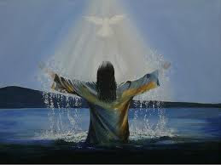

Gospel: Luke 3:15-16, 21-22
People's hopes began to rise, and they began to wonder whether John perhaps might be the Messiah. So John said to all of them, “I baptize you with water, but someone is coming who is much greater than I am. I am not good enough even to untie his sandals. He will baptize you with the Holy Spirit and fire.
After all the people had been baptized, Jesus also was baptized. While he was praying, heaven was opened, and the Holy Spirit came down upon him in bodily form like a dove. And a voice came from heaven, “You are my own dear Son. I am pleased with you.”

