Sunday 2nd January 2022
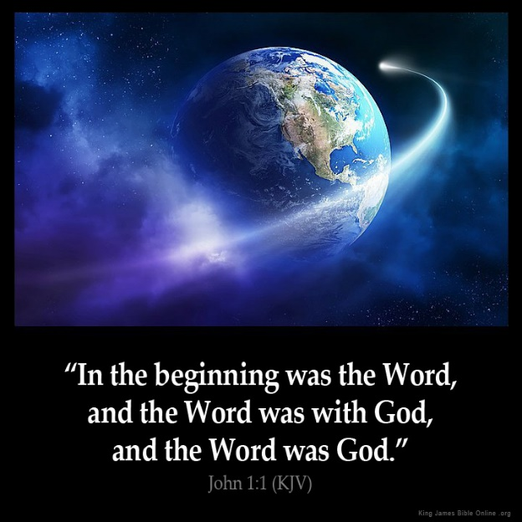
Gospel: John 1:1-18 (short version in bold John 1:1-5, 9-14)
In the beginning the Word already existed; the Word was with God, and the Word was God. From the very beginning the Word was with God. Through him God made all things; not one thing in all creation was made without him. The Word was the source of life, and this life brought light to humanity. The light shines in the darkness, and the darkness has never put it out.
God sent his messenger, a man named John, who came to tell people about the light, so that all should hear the message and believe. He himself was not the light; he came to tell about the light. This was the real light—the light that comes into the world and shines on everyone.
The Word was in the world, and though God made the world through him, yet the world did not recognize him. He came to his own country, but his own people did not receive him. Some, however, did receive him and believed in him; so he gave them the right to become God's children. They did not become God's children by natural means, that is, by being born as the children of a human father; God himself was their Father.
The Word became a human being and, full of grace and truth, lived among us. We saw his glory, the glory which he received as the Father's only Son.
John spoke about him. He cried out, “This is the one I was talking about when I said, ‘He comes after me, but he is greater than I am, because he existed before I was born.’”
Out of the fullness of his grace he has blessed us all, giving us one blessing after another. God gave the Law through Moses, but grace and truth came through Jesus Christ. No one has ever seen God. The only Son, who is the same as God and is at the Father's side, he has made him known.

