Sunday 16th January

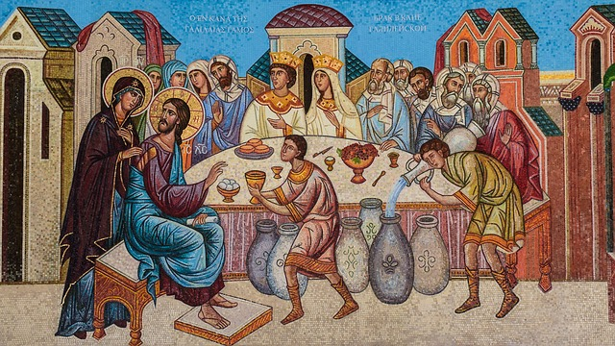

Gospel: John 2:1-11
Two days later there was a wedding in the town of Cana in Galilee. Jesus' mother was there, and Jesus and his disciples had also been invited to the wedding. When the wine had given out, Jesus' mother said to him, “They have no wine left.”
“You must not tell me what to do,” Jesus replied. “My time has not yet come.”
Jesus' mother then told the servants, “Do whatever he tells you.”
The Jews have rules about ritual washing, and for this purpose six stone water jars were there, each one large enough to hold about a hundred litres. Jesus said to the servants, “Fill these jars with water.” They filled them to the brim, and then he told them, “Now draw some water out and take it to the man in charge of the feast.” They took him the water, which now had turned into wine, and he tasted it. He did not know where this wine had come from (but, of course, the servants who had drawn out the water knew); so he called the bridegroom and said to him, “Everyone else serves the best wine first, and after the guests have had plenty to drink, he serves the ordinary wine. But you have kept the best wine until now!”
Jesus performed this first miracle in Cana in Galilee; there he revealed his glory, and his disciples believed in him.
