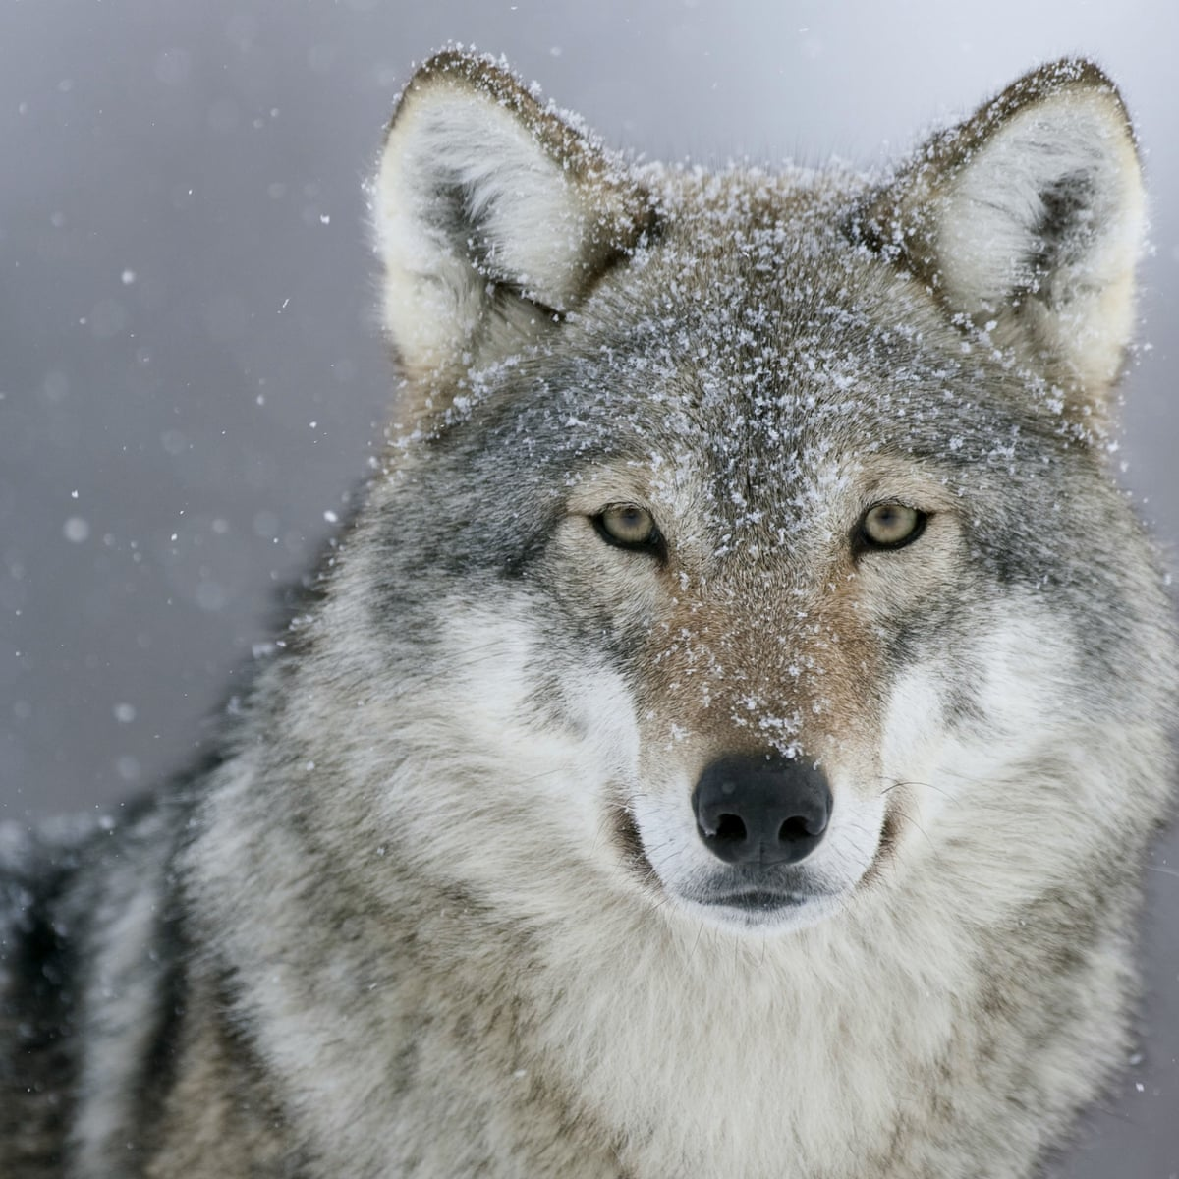

**GEOGRAPHY**

Northern & Southern Hemisphere – equator – Artic – Antarctic – Tropic of Cancer & Capricorn – temperate regions – Fair Trade – drought and famine – global trade

<https://schools.fairtrade.org.uk/teaching-resources/make-bananas-fair-a-film-for-schools/>

RE

Judaism – Passover – Yom Kippur – tolerance – expectation – excitement – patience – waiting – gifts – Nativity – symbolism – Light of The World

<https://www.bbc.co.uk/programmes/p02n2kt9>

<https://www.youtube.com/watch?v=yXWoKi5x3lw>

PE

Dance – rhythm – football – control – pace – balance – beat – performance

<https://www.bbc.co.uk/programmes/p05cmdlx>

**SCIENCE**

Classifying – Venn diagrams – grouping – life cycles – reproduction – mammals – deforestation – loss of habitat – endangered – extinct

<https://www.youtube.com/watch?v=ITrRMiQB8g4>

<https://www.bbc.co.uk/programmes/p0174rrm>

COMPUTING

Research – blogs – maps – recording – evaluating -

<https://www.youtube.com/watch?v=GAXBz5kC3CQ>

**MUSIC**

Ukulele – pace – rhythm – tune – listen and repeat back

<https://www.youtube.com/watch?v=5bTE5fbxDsc>

**LITERACY VOCABULARY**

Narratives – myths and legends – analyse and evaluate – make predictions – advertisements – formal speeches – electronic texts – formal debates – discussion texts – performance poetry – standard English

[www.bbc.co.uk/bitesize/topics/zxvv4wx](http://www.bbc.co.uk/bitesize/topics/zxvv4wx)

<https://www.youtube.com/watch?v=wFCcbFtd6Zo>

**MATHS**

Multiply – divide – share- product – lots of – groups of– area - conversion – perimeter – length

<https://www.bbc.co.uk/iplayer/episode/m000wxdt/sign/bitesize-911-year-olds-maths-12-multiplication?seriesId=p089g0cc-unindexed>

<https://www.bbc.co.uk/iplayer/episode/p08b5l9c/bitesize-79-year-olds-teacher-talks-2-maths-multiplying-and-dividing>