Sunday 28th November
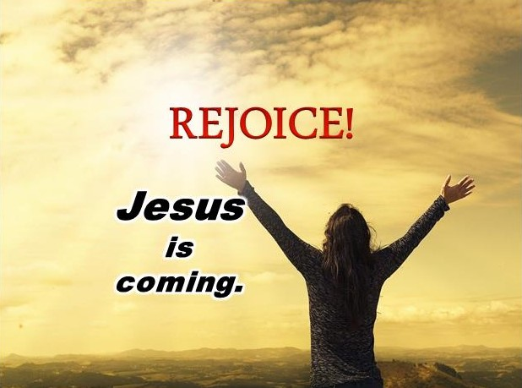
Gospel: Luke 21:25-28, 34-36
“There will be strange things happening to the sun, the moon, and the stars. On earth whole countries will be in despair, afraid of the roar of the sea and the raging tides. People will faint from fear as they wait for what is coming over the whole earth, for the powers in space will be driven from their courses. Then the Son of Man will appear, coming in a cloud with great power and glory. When these things begin to happen, stand up and raise your heads, because your salvation is near.”

“Be on your guard. Don’t let yourselves become occupied with too much feasting and drinking and with the worries of this life, or that Day may suddenly catch you like a trap. For it will come upon all people everywhere on earth. Be on the alert and pray always that you will have the strength to go safely through all those things that will happen and to stand before the Son of Man.”

We do not know when Jesus will come again, but in today’s gospel Jesus tells us to pray and to watch how we behave while we are waiting, so that we will be ready when he comes. How do you think Jesus wants us to behave? How do you think he would like us to treat other people both here and around the world?

Jesus asks us to love one another and to treat other people as we want to be treated. Whether they’re in our own family or on the other side of the world.

