Messengers of hope

Monday 29th November 2021
The chaplaincy team led us in worship this morning.
They read their messages of hope for different groups of people.
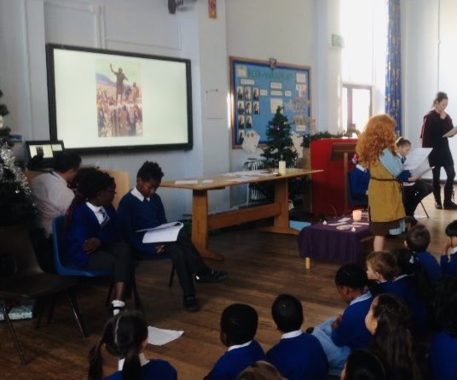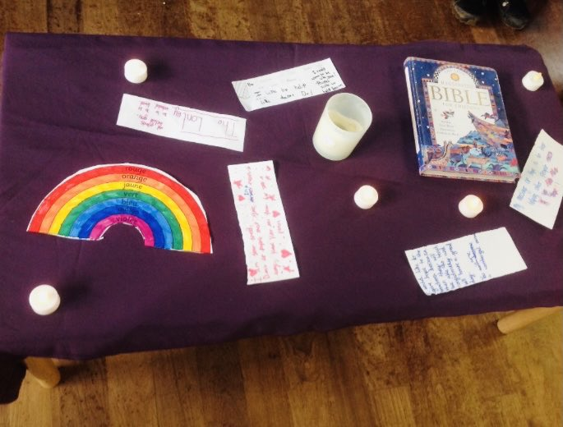
Our Mission this week is to write our own message of hope for someone who needs it.

