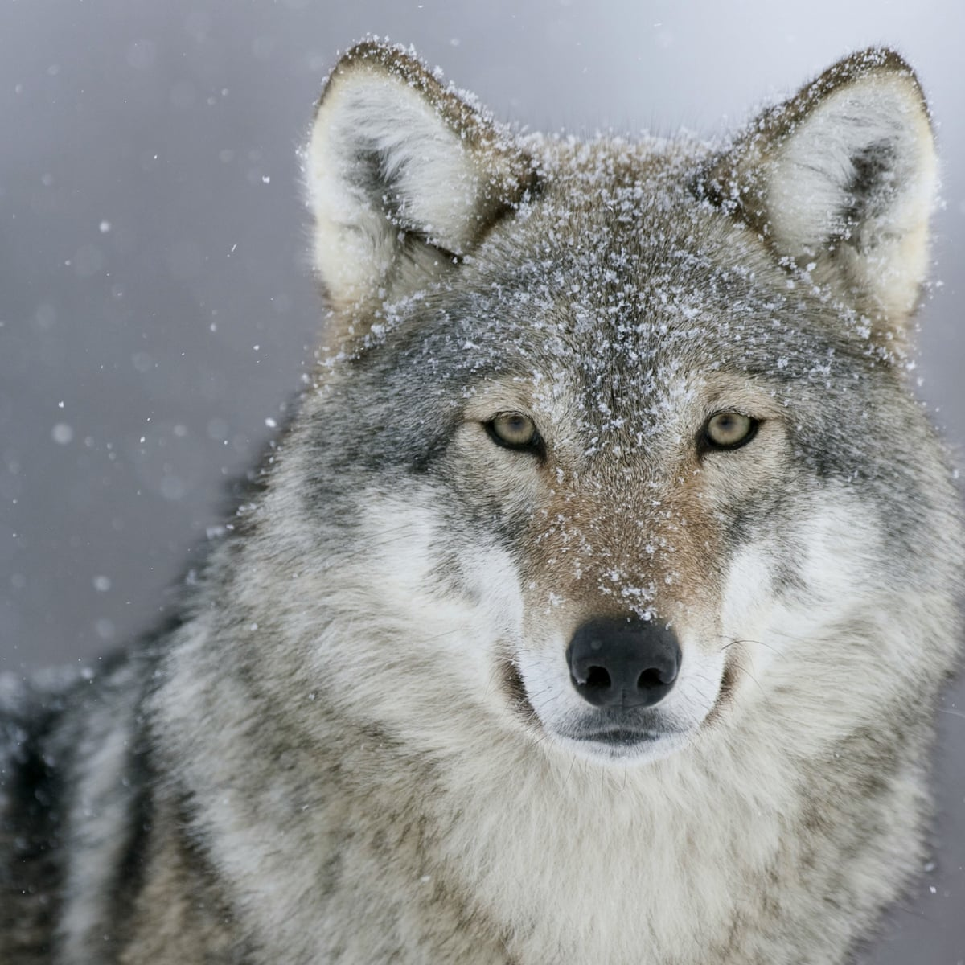

MATHS

We will continue this year’s math journey by using our knowledge to understand the core concepts of multiplication and division. The children will then move on to study length, area and perimeter, along with continuing to improve their knowledge of their times tables.

RE

Our RE topics are Judaism and Hope. Pupils will explore the fascinating religion of Judaism, learning more about the faiths of others. Children will deepen their understanding of Advent and building their excitement of the coming of Jesus. We will be giving reasons and making links to scripture.

MUSIC

During our Advent term, the children will be learning to play the ukulele and explore the different components required when reading music.

PE

During the run up to Christmas, children will be developing their individual skills in gymnastics and dance along with harnessing their team work in football.

SCIENCE

Our science topic is Living Things and Their Habitats. We will be learning about how different habitats support the wildlife found there. We will be classifying animals, using sorting diagrams along with developing an understanding of animals have adapted to thrive in their environments.

GEOGRAPHY

Our children will be learning about the lines of latitude of the world, temperate regions and how weather has a big impact on what is grown around the world. The children will be investigating Fair Trade, the route our food takes from the farm to the plate and finding out why certain places face drought and famine.

LITERACY

During our exciting Hunted topic children will be exploring folk tales. They will be writing their own narrative based on the novel we’ve been reading in class. As a class we will be creating debates and providing a balanced argument. We will also be writing and performing a piece of poetry linked to a theme.

COMPUTING

They children will be using the internet to research where different food comes from and creating their own blogs.

DT

During this topic our design focus will be on food. Children will be researching and making a product for a stated purpose and user. They will then be reflecting and evaluating their product.

**Hunted**

**Year 4/5**