1st Sunday of Advent - Sunday 28th November

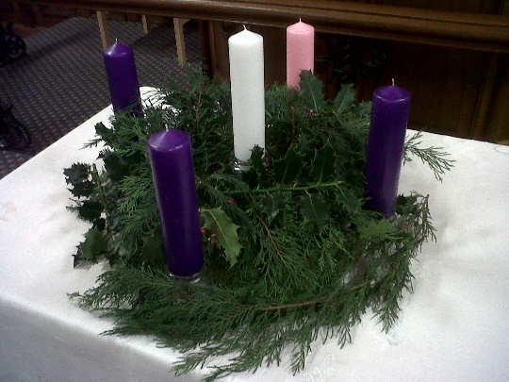The Advent wreath helps us prepare for Christmas. The circular shape has no beginning and no end – it reminds us that life with Jesus is everlasting. The evergreen leaves show God’s love for us never ends. The candles remind us that Jesus is the light of the world.

Prayers

Come Lord, come again
Come Lord, your wounded world is yearning
for you to come again.
Come Lord, your weary world is crying out
for you to lift us up
out of our despair, our hunger,
our thirst for something better,
our need for the food that will last.
Come Lord, come again,
we need to begin again.
Sue Allerton/CAFOD

God of hope
God of hope,
we cling to you,
for your renew the face of the earth.
Through the gift of your Son,
our Lord Jesus,
we follow you on the path of dawn.
Enlightened by your love and wisdom,
help us to lead each other
and all creatures
back to your open arms.
Amen.
Rachel McCarthy/CAFOD

