Sunday 7th November
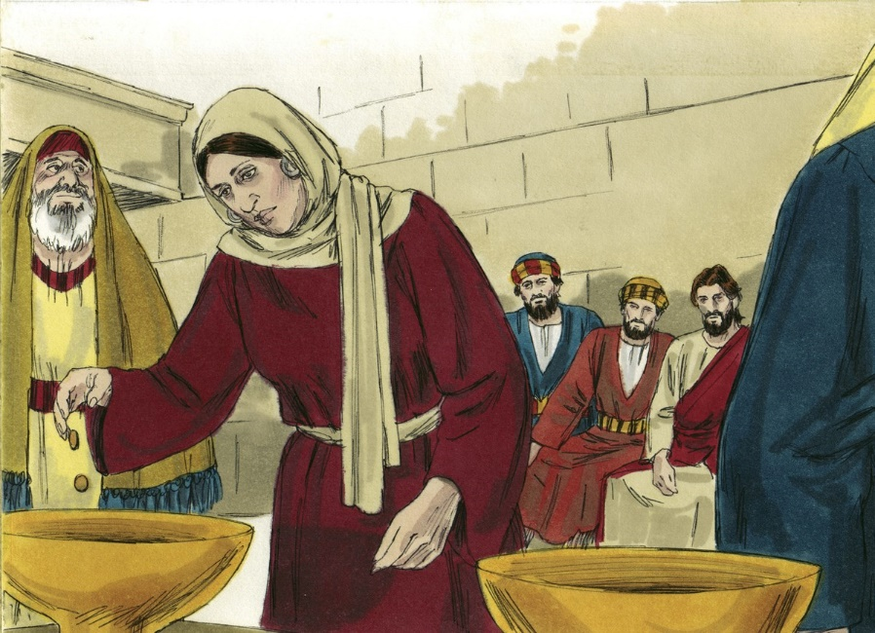
Gospel: Mark 12:38-44
As he taught them, [Jesus] said, “Watch out for the teachers of the Law, who like to walk around in their long robes and be greeted with respect in the marketplace, who choose the reserved seats in the synagogues and the best places at feasts. They take advantage of widows and rob them of their homes, and then make a show of saying long prayers. Their punishment will be all the worse!”
As Jesus sat near the temple treasury, he watched the people as they dropped in their money. Many rich men dropped in a lot of money; then a poor widow came along and dropped in two little copper coins, worth about a penny. He called his disciples together and said to them, “I tell you that this poor widow put more in the offering box than all the others. For the others put in what they had to spare of their riches; but she, poor as she is, put in all she had—she gave all she had to live on.”

