Sunday 31st October
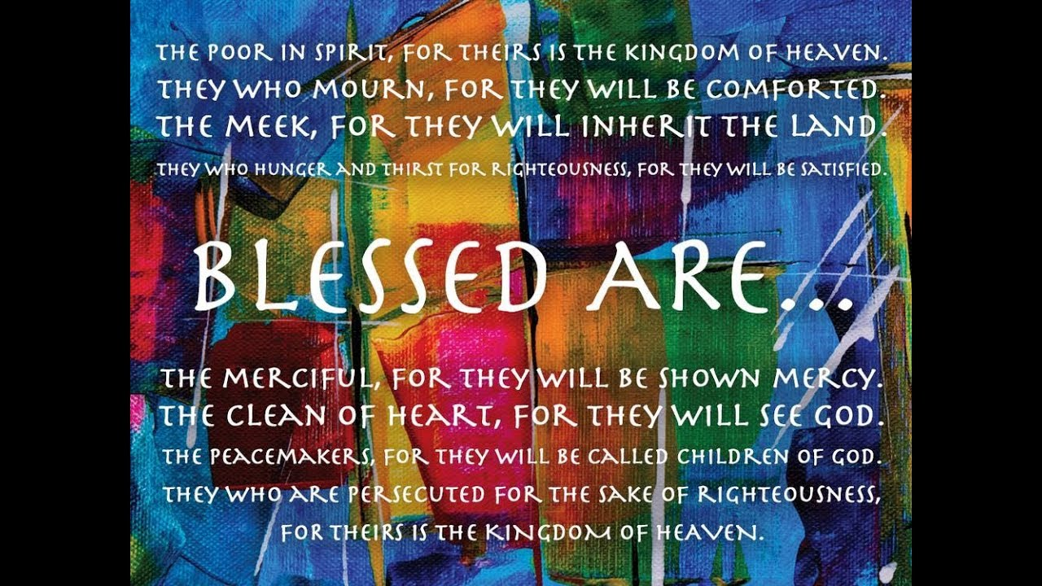

Gospel: Matthew 5:1-12
Jesus saw the crowds and went up a hill, where he sat down. His disciples gathered round him, and he began to teach them:
“Happy are those who know they are spiritually poor;
the Kingdom of heaven belongs to them!
“Happy are those who mourn;
God will comfort them!
“Happy are those who are humble;
they will receive what God has promised!
“Happy are those whose greatest desire is to do what God requires;
God will satisfy them fully!
“Happy are those who are merciful to others;
God will be merciful to them!
“Happy are the pure in heart;
they will see God!
“Happy are those who work for peace;
God will call them his children!
“Happy are those who are persecuted because they do what God requires;
the Kingdom of heaven belongs to them!
“Happy are you when people insult you and persecute you and tell all kinds of evil lies against you because you are my followers. Be happy and glad, for a great reward is kept for you in heaven. This is how the prophets who lived before you were persecuted.

